Components Configuration Guide

Contents

1 Overview 5

2 How to Edit a Page 5

3 How to Add a Web Part 5

4 How to Edit a Web Part 7

5 How to Publish a Page 7

6 How to Navigate to a List 8

7 DOSNP – Dashboard 9

7.1 Properties 9

7.2 Configure DOSNP - Dashboard 10

7.3 Configure Web Part Tasks 13

8 DOSNP - Carousel 17

8.1 Prerequisites 17

8.2 Properties 17

8.3 Configure DOSNP - Carousel web part 18

8.4 Image specifications 29

9 DOSNP - Call to Action 29

9.1 Prerequisites 29

9.2 Properties 29

9.3 Configure DOSNP - Call to Action 30

10 DOSNP - New Hire 34

10.1 Prerequisites 34

10.2 Properties 34

10.3 Configure DOSNP - New Hire 35

11 DOSNP - Notice Board 44

11.1 Prerequisites 44

11.2 Properties 44

11.3 Configure DOSNP - Notice Board 45

12 DOSNP - Featured Links 50

12.1 Prerequisites 50

12.2 Properties 50

12.3 Configure DOSNP - Featured Links 52

13 DOSNP - Breadcrumb 67

13.1 Prerequisites 67

13.2 Properties 67

13.3 Configure DOSNP - Breadcrumb 68

14 DOSNP - Navigation 71

14.1 prerequisites 71

14.2 Properties 71

14.3 Configure DOSNP - Navigation 72

15 DOSNP - Accordion 77

15.1 Prerequisites 77

15.2 Properties 77

15.3 Configure DOSNP - Accordion 78

16 DOSNP - Document Card 87

16.1 Prerequisites 87

16.2 Properties 87

16.3 Configure DOSNP - Document Card 88

17 DOSNP - Testimonials 101

17.1 Prerequisites 101

17.2 Properties 101

17.3 Configure DOSNP Testimonials 102

18 DOSNP - Key Contacts 110

18.1 Prerequisites 110

18.2 Properties 110

18.3 Configure Key Contacts 111

19 DOSNP - Thumbnail Carousel 118

19.1 Prerequisites 118

19.2 Properties 118

19.3 Configure DOSNP - Thumbnail Carousel 119

20 DOSNP - Multi Layout Editor 127

20.1 Properties 127

20.2 Configure DOSNP - Multi Layout Editor 127

21 DOSNP - Render HTML 133

21.1 Prerequisites 133

21.2 Properties 134

21.3 Configure DOSNP - Render HTML 134

22 DOSNP - Events Calendar 139

22.1 Prerequisites 139

22.2 Properties 139

22.3 How to Create Events Calendar List 141

22.4 Configure DOSNP - Events Calendar 142

22.5 Registration Process 147

22.5.1 Register as Attendee 147

22.5.2 Register as Presenter 148

23 DOSNP - Extension 149

23.1 Configurations 149

23.2 Edit Configurations from Dashboard 149

23.3 Edit Configurations List 149

24 DOSNP - Repository 152

24.1 Prerequisites 152

24.2 Properties 152

24.3 Configure DOSNP - Repository 153

25 DOSNP – Featured Content 159

25.1 Prerequisites 159

25.2 Properties 159

25.3 Configure DOSNP – Featured Content 160

26 DOSNP – My Favorites 162

26.1 Prerequisites 162

26.2 Properties 162

26.3 Configure DOSNP – My Favorites 163

27 Clear the Cache 168

27.1 Clearing the Local Cache 168

27.2 Clearing the Cache from List 168

# Overview

This document will help you in configuring all custom reusable components that are created as part of RA migration.

# How to Edit a Page

* Open the site page and click on **Edit** button as shown below.

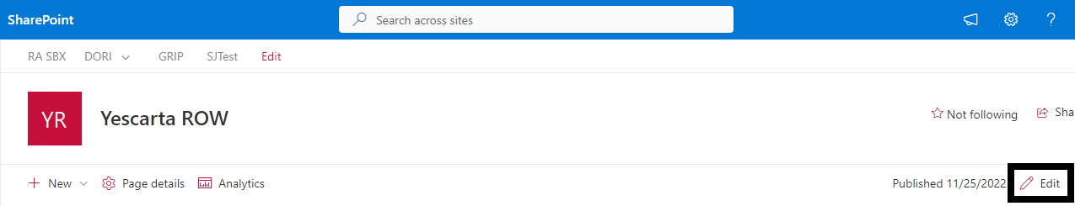

* Page will be opened in edit mode as shown below.

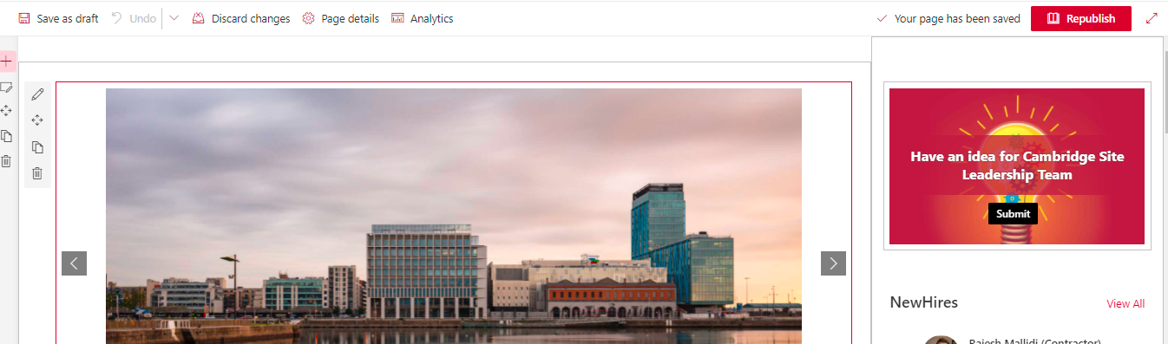

* Edit the required details.

# How to Add a Web Part

* Edit a page (refer how to edit a page). Once the page is in edit mode, click on the section where the new web part needs to be added.
* Click on highlighted icon to add a new web part.

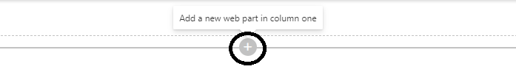

* A new panel will be opened as shown below.

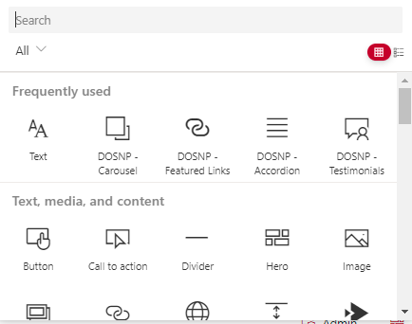

* Select any web part or search for a specific web part to add.

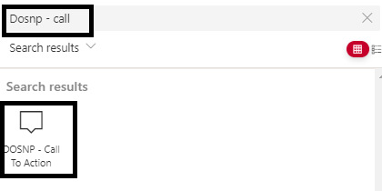

* Selected web part will be added to the page.

# How to Edit a Web Part

* Edit a page (refer how to edit a page). Once the page is in edit mode, click on the web part and click on edit web part icon as shown below.

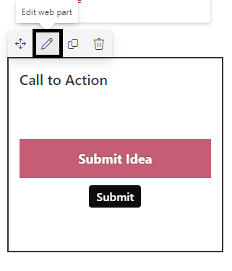

* A new web part property panel will be opened.
* Update the required properties and click on Apply button.

# How to Publish a Page

* Once the page editing is completed, click on the republish button as shown below.

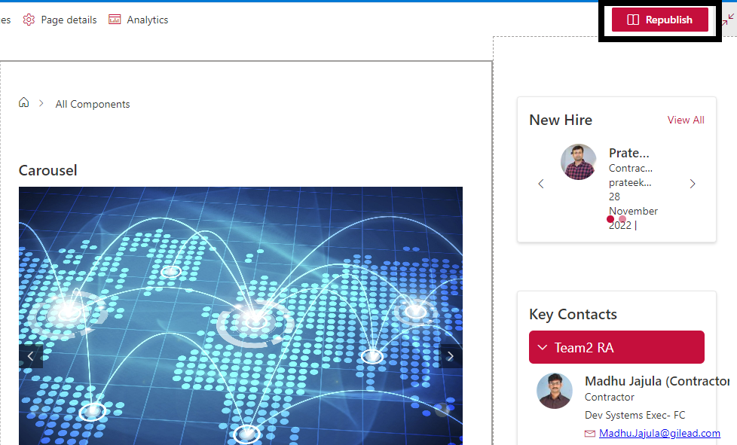

* Page will be published.

# How to Navigate to a List

* Open the site and click on settings icon and click on site contents link.

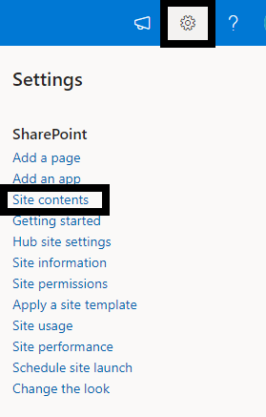

* A new page will be opened with all the lists as shown below.

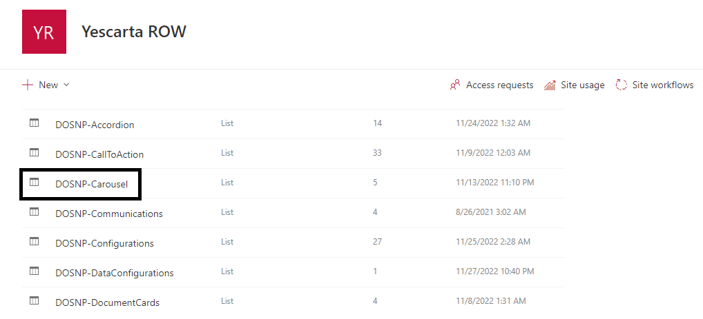

* Select the required list Ex: DOSNP-Carousel.
* DOSNP-Carousel list will be opened.

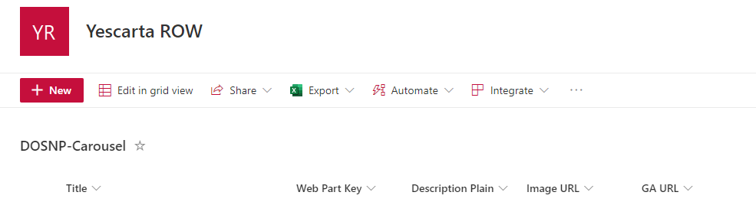

# DOSNP – Dashboard

## Properties

|  |  |  |  |
| --- | --- | --- | --- |
| Webpart Properties | Description | Values/Specifications | Comments |
| Title | Specifies the web part title | Any string value |  |
| Description | Specifies the web part description | Any string value |  |
| Configure Links Data | Specify all the links that needs to be displayed under super user tab |  |  |

## Configure DOSNP - Dashboard

* Create a Dashboard page.
* Edit the site page (refer how to edit a page section) and add **DOSNP - Dashboard** web part to the page (refer how to add a web part section).
* Edit the web part (refer how to edit a web part), a new panel will be opened as below.

* Enter title and description field values.
* Click on **Configure Links Data** button to configure links displayed in super user tab. A new panel will be opened as below.

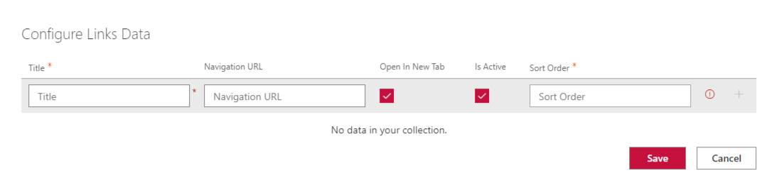

* Enter **Title**, **Navigation URL**, **Sort Order** values.
* Select **Open in New Tab** to open a link in new tab.
* Select **Is active** to display the link. Else the link item will not appear.
* Click on **+ icon** to add a new row.

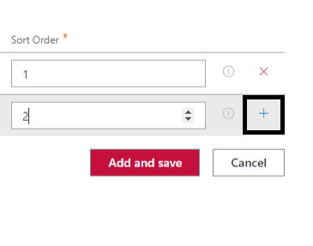

* Enter all the links information.

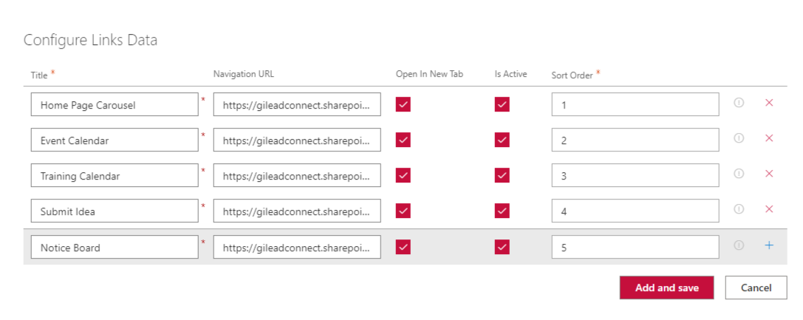

* Click on Add and save button.

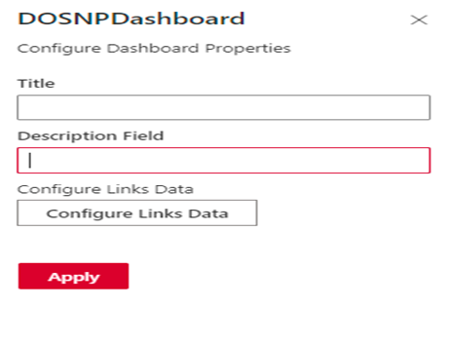

* Click on **Apply** button.
* Save and publish the page.
* DOSNP - Dashboard web part configuration will be completed and below screen will be displayed.

***Admin view***

***Super User view***

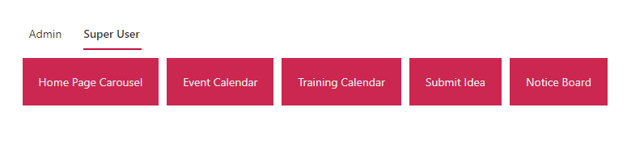

* Only admin users (with Manage Permissions, Manage Lists, Delete Versions) can see both admin and Super User tabs.
* Contributors (with Add List Items, Edit List Items and View Versions) can only see Super User tab.

## Configure Web Part Tasks

* Here is the list of all tasks that are being used in configuring prerequisites of all the custom reusable components.
* Each web part will be associated with one or more tasks listed below.

#### Create Fields

* Select required web part from the dropdown list. All the associated web part tasks will be displayed for the selected web part.

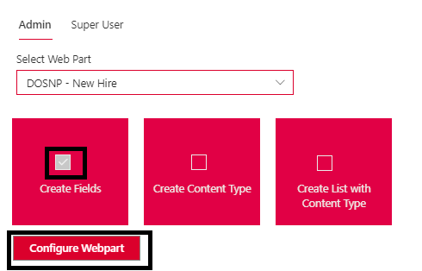

* Select Create Fields checkbox. configure web part button will be enabled.
* Click on configure web part button.
* If the fields are already created, this checkbox will be in disabled mode.
* You can select multiple tasks at a time and configure the web part.

#### Create Content Type

* Select required web part from the dropdown list. All the associated web part tasks will be displayed for the selected web part.

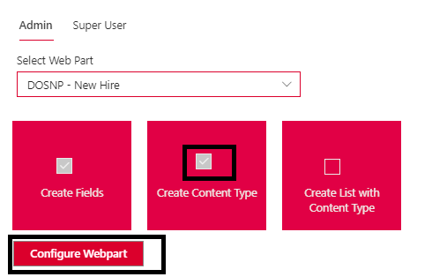

* Select Create Content Type checkbox. configure web part button will be enabled
* Click on configure web part button.
* If the content types are already created, this task will be in disabled mode.
* You can select multiple tasks at a time and configure the web part.

#### Create List with Content Type

* Select required web part from the dropdown list. All the associated web part tasks will be displayed for the selected web part.

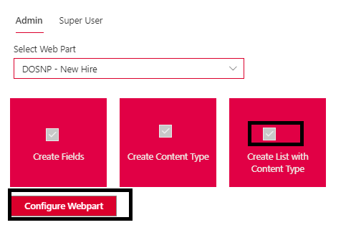

* Select Create List with Content Type checkbox. Configure web part button will be enabled.
* Click on configure web part button.
* If the Lists are already created, this task will be in disabled mode.
* You can select multiple tasks at a time and configure the web parts.

#### Add Configurations

* Select required web part from the dropdown list. All the associated web part tasks will be displayed for the selected web part.

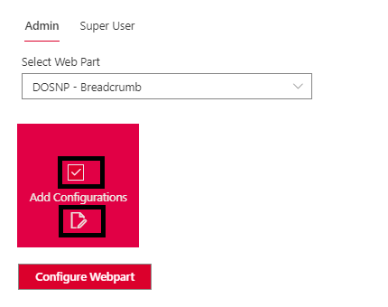

* Select Add Configurations checkbox, configure web part button will be enabled.
* Edit configuration values by clicking on the edit icon as shown above.

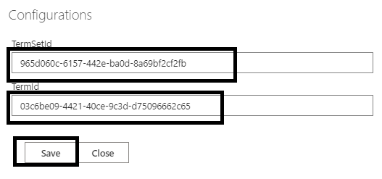

* Enter configuration values and click on save button.
* Click on configure web part button.

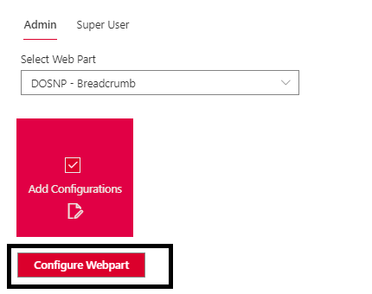

* This will add/modify configuration entries in the configuration list.
* You can select multiple tasks at a time and configure the web parts.

# DOSNP - Carousel

## Prerequisites

Configure below web part tasks using **DOSNP - Dashboard** web part. Please refer **Configure Web Part Tasks** section in DOSNP - Dashboard web part.

1. Create Fields
2. Create Content Type
3. Create List with Content Type

## Properties

|  |  |  |  |
| --- | --- | --- | --- |
| Webpart Properties | Description | Values/Specifications | Comments |
| Title | Specifies the web part title | Any string value | Title value will be displayed as a web part heading. If there is no title specified, then there is no heading. |
| Select Data Source | Select the data source to display carousel images | * List * Library * Properties | Images can be displayed from any selected data source |
| List Name | Specify the list name to display images | Default value is ‘**DOSPN-Carousel**’ | This is a read only field and applicable only if the data source is **List** |
| Web Part Key | Specify web part key to retrieve filtered images from a List | Default value is  ‘**RATestCarousel**' | Applicable only if the data source is **List** |
| Library Relative Path | Specify a path to display images from Library | Any library path or folder path | Applicable only if the data source is **Library** |
| Configure Data | Specify all image item details to display items from Properties | Provide all the item details | Applicable only if the data source is **Properties** |
| Number Of Items To Display | Specify the item limit display in carousel |  |  |
| Interval In Milliseconds | Specify the amount of time to delay between automatically cycling an item | Default value is 5 seconds |  |
| Pause On Hover | Specifies if slides cycling should pause when hovering over the content | * True * False | Default value is **True** |
| Is Infinite | Indicates if infinite scrolling is enabled | * True * False | Default value is **True** |
| Show Indicators | Specifies if set of slide position indicators is shown | * True * False | Default value is **True** |
| Show Details | Specifies if the details are shown on hover or constantly | * True * False | Default value is **True** |
| Indicator Shape | Specifies the indicator shape | * Circle * Square * Rectangle | Default value is **Circle** |
| Chevron Icon Display Type | Specifies the buttons container display mode | * Buttons Only * Hidden | Default value is **Buttons Only** |
| Image Fit | Specifies the image display type | * Cover * Contain * Fill | Default value is **Cover** |
| Carousel Height | Specify the carousel height |  | Width will be auto, and height can be specified |

## Configure DOSNP - Carousel web part

Edit the site page (refer how to edit a page) and add DOSNP - Carousel web part (refer how to add a web part) to the page. This web part can be configured from 3 different data sources.

* List
* Library
* Properties

#### Configure from List

#### Add data to List

* Navigate to DOSNP-Carousel list (refer how to navigate to a list).
* A new page will be opened as below. Click on New button.

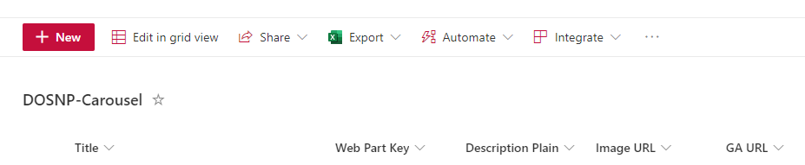

* A new panel will be opened as below.

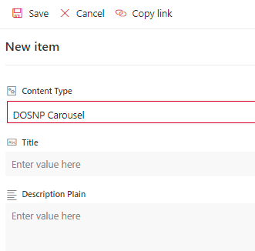

* Enter Title, Description Plain values.
* Enter Image URL. This image will be displayed in the carousel.
* Enter GA URL to open a link when click on an item.
* Select Open in New Tab to open a link in new tab.
* Select Is Active to display the item in carousel. Else item won’t be displayed in carousel.
* Enter sort order to sort items.
* Enter web part key. Make sure to configure this value in web part properties.

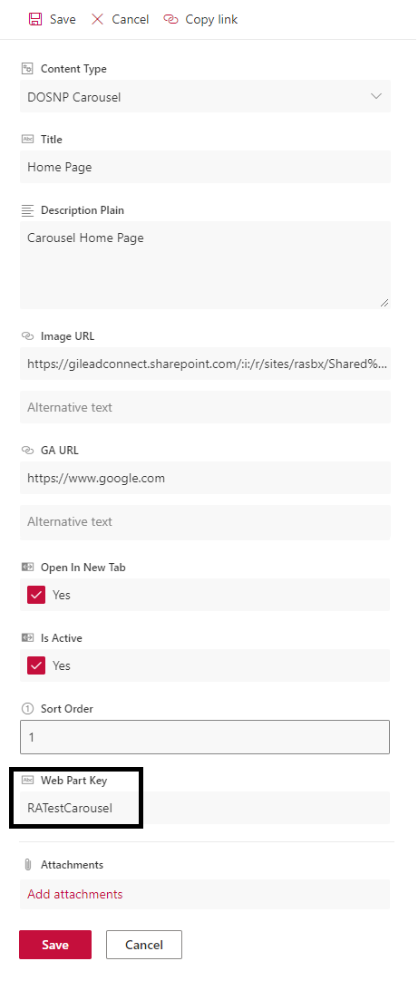

* Click on Save button.
* Item details will be saved into the list.

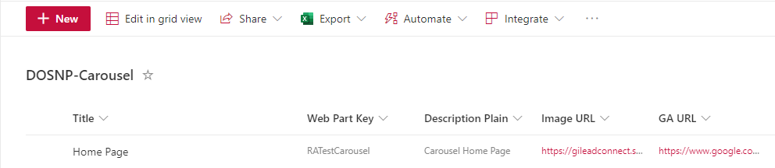

#### Retrieve data from List

* Click on edit web part (refer how to edit a web part). Web part property panel will be opened.

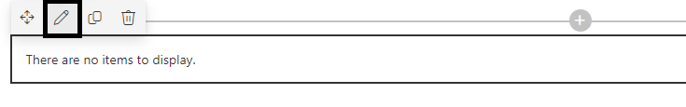

* Select data source as List and enter Web Part Key (This is the value mentioned while adding a new item into the list) and click on Next button as shown below.

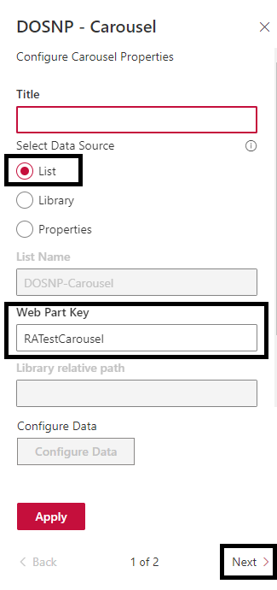

* Configure other web part properties as shown below and click on apply button.

* Images from DOSNP-Carousel list with Web Part Key mentioned above will start appearing in the carousel.
* Save the page and publish the page.

#### Configure from Library

* Edit the web part and select Library as the selected data source and enter Library Relative Path. This relative path can be any library path with images.

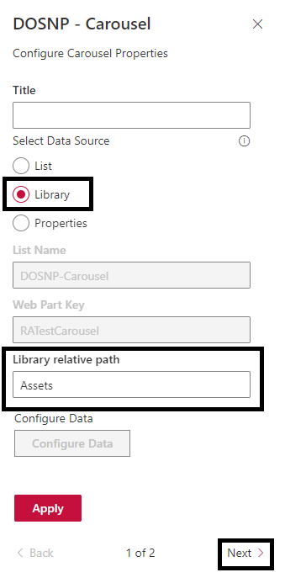

* Configure the other web part properties as shown below and click on apply button.

* Images from the above Library Relative Path will start appearing in the carousel.
* Save and publish the page.

#### Configure from Properties

* Edit the web part and select Properties as selected data source and click on Configure Data button.

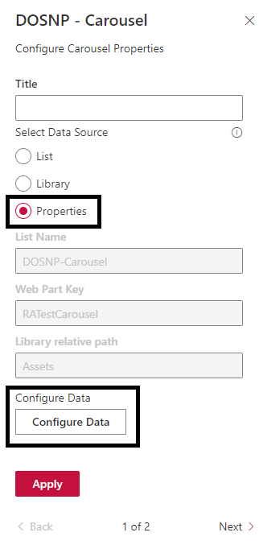

* A new web part property panel will be opened as shown below.

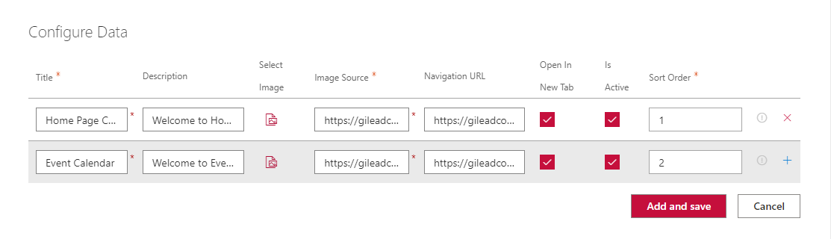

* Enter Title, Description, Navigation URL, Sort Order and select image by clicking on select image button.
* Make sure Is Active is checked to display the item in carousel, otherwise the item won’t be displayed.
* Make sure Open in New Tab is checked to open the link in new tab.
* To add a new item detail, click on + button as shown below.

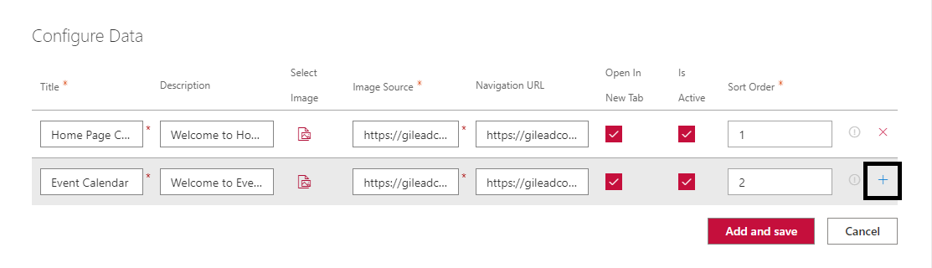

* A new empty row will be added as shown below.

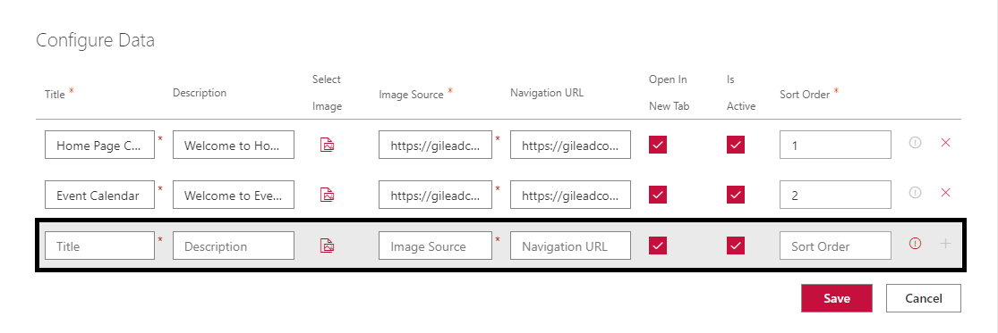

* Enter all the details and click on Save button.

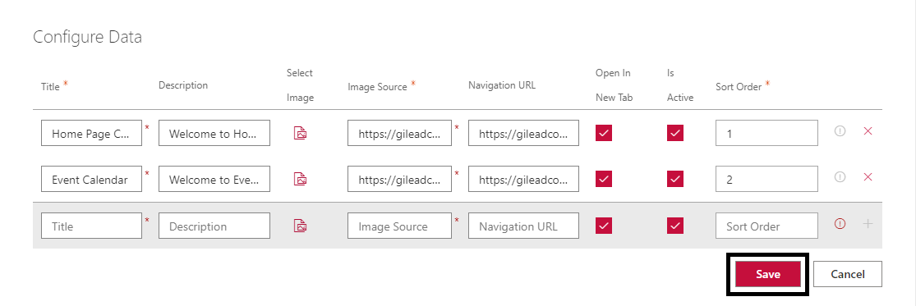

* Configure other web part properties as shown below and click on apply button.

* Save the page and publish it.

## Image specifications

* Image width: Auto
* Image height: Default value is 450 px. This can be adjusted using web part properties.

# DOSNP - Call to Action

## Prerequisites

Configure below web part tasks using **DOSNP - Dashboard** web part. Please refer **Configure Web Part Tasks** section in DOSNP - Dashboard web part.

1. Create Fields
2. Create Content Type
3. Create List with Content Type

## Properties

|  |  |  |  |
| --- | --- | --- | --- |
| Webpart Properties | Description | Values/Specifications | Comments |
| Title | Specifies the web part title | Any string value | Title value will be displayed as a web part heading. If there is no title specified, then there is no heading. |
| Select webpart type | Select the webpart type to configure preferable webpart | * Submit Idea * Subscriptions * Scroll | Three type of web parts can be configured using a single web part |
| Web Part Key | Specify web part key to retrieve filtered items from a List | Any string value |  |
| List Name | Specify the list name to save submitted ideas or subscription details | * For webpart type **‘**Submit Idea**’** Default value is ‘**DOSNP-CallToAction’.** * For webpart type **‘**Subscriptions**’** Default value is ‘**DOSNP-EmailSubscribers’.** | This is a read only field |
| Header Message | Specify a header message to display on top of the image | Any string value |  |
| Button Name | Specify button display text | Any string value | Default value is **Submit** |
| Email Template Key | Specify the email template used to send emails | Default value is **‘Home_CallToAction’** |  |
| Success Message | Specify the success message to display after submitting the idea | Default value is “The idea has been submitted successfully”. |  |
| Click here to Select Image | Select the relevant image to display |  |  |
| Button Horizontal Position | Specifies the submit button horizontal position | * Left * Right * Center | Default value is Center |
| Button Vertical Position | Specifies the submit button vertical position | * Top * Bottom * Center | Default value is Center |
| Submit Button Text Color | Specifies the submit button text color |  |  |
| Submit Button Background Color | Specifies the submit button background color |  |  |
| Scroll Image URL | Specifies image url to display the image to scroll |  |  |
| Selector | Specify selector to scroll the image |  |  |
| Image Position | Specify Image position to display | * Left * Right * Center | Default value is Center |
| Enable Target Audience | Specify if target audience needs to be enabled | * True * False |  |
| Type of audience target | Specify target audience type | * Security Group * Office Location | Target Audience can be enabled based on Security group or office location. |
| Security Group Details (separated by semicolon) | Name of the groups that needs to be targeted |  | Separated by semicolon |
| Location Details (separated by semicolon) | Name of the location that needs to be targeted |  | Separated by semicolon |

## Configure DOSNP - Call to Action

Edit the site page (refer how to edit a page) and add **DOSNP - Call to Action** web part (refer how to add a web part) to the page. This can be configured as three different type of web parts.

* Submit Idea
* Subscriptions
* Scroll

#### Configure Submit Idea

* Edit the DOSNP - Call to Action web part.

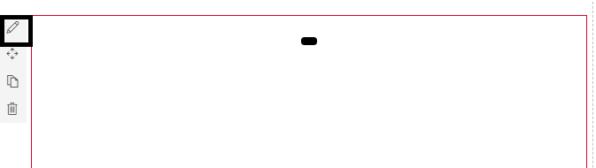

* Web part property panel will be opened. Enter all the details.

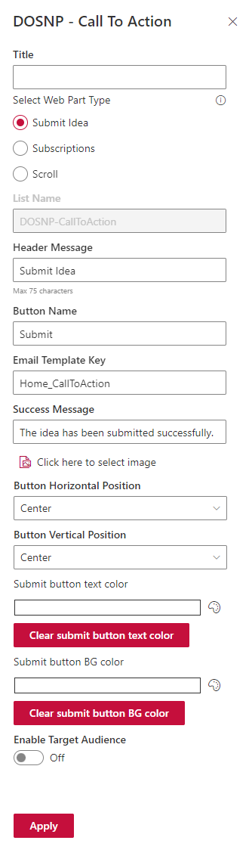

* Select web part type as Submit Idea.
* Enter Header Message, Button Name, Email Template Key, Success Message properties as shown above.
* Click on “Click here to select image” button to select image.
* Select Button Horizontal Position, Button Vertical Position, Submit Button Text Color, Submit Button Background Color.
* Click on Apply button.
* Save and publish the page.

#### Configure Subscriptions

* Edit the DOSNP - Call to Action web part. Web part property panel will be opened as shown below.
* Select Subscriptions as web part type.
* Enter Web Part Key and click on Apply button as shown below.

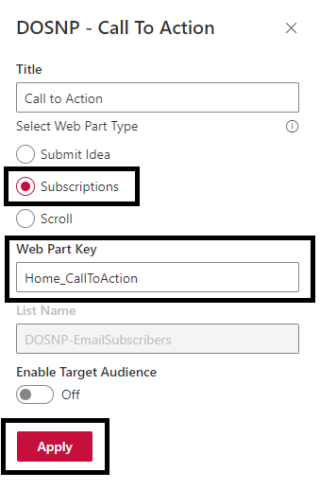

* Save and publish the page.
* Subscription’s icon will be displayed on the page as shown below.



# DOSNP - New Hire

## Prerequisites

Configure below web part tasks using **DOSNP - Dashboard** web part. Please refer **Configure Web Part Tasks** section in DOSNP - Dashboard web part.

1. Create Fields
2. Create Content Type
3. Create List with Content Type

## Properties

|  |  |  |  |
| --- | --- | --- | --- |
| Webpart Properties | Description | Values/Specifications | Comments |
| Title | Specifies the web part title | Any string value | Title value will be displayed as a web part heading. If there is no title specified, then there is no heading. |
| Select Data Source | Select the data source to display New Hire items | * List * Service * JSON | New Hire items can be displayed from any selected data source |
| List Name | Specify the list name to display New Hire items | Default value is ‘**DOSNP-NewHire’** | This is a read only field and applicable only if the data source is **List** |
| Web Part Key | Specify web part key to retrieve filtered items from List | Any String value | Applicable only if the data source is a **List** |
| Service Type | Specify Service Type to get New Hire items | * Location * Manager | Applicable only if the data source is **Service** |
| Enter Location Name | Specify location name to get New Hire items | Any String value | Applicable only if the data source is **Service** |
| Enter Number of Days | Specify number of days to retrieve data from past days | Integer value | Ex: 60. This will get the New Hires from past 60 days |
| Enter Manager ID | Specify manager id to get New Hires under a user | Integer value |  |
| JSON File Path | Specify JSON file path to get New Hire items | File path |  |
| Number of Items to Display | Specify the item limit display in New Hires | Any Integer value |  |
| Data To Be Displayed | Select checkboxes to display data | * Email * Location * Joining Date |  |
| Date Format | Specifies the date format | Default value is ‘**DD MMMM YYYY’** | A valid Date Format should be in UPPER CASE only |
| Display Mode | Specifies how New Hires should displayed | * Carousel * List | * Select Carousel to display New Hires in Carousel Mode. * Select List to display New Hires in List Mode. |
| Interval in Milliseconds | Specify the amount of time to delay between automatically cycling an item | Default value is 3 seconds |  |
| Show Indicators | Specifies if set of slide position indicators is shown | * True * False | Default value is True |
| Chevron Icon Display Type | Specifies the buttons container display mode | * Block * Hidden | Default value is Block |

## Configure DOSNP - New Hire

Edit the site page and add **DOSNP - New Hire** web part to the page. This can be configured from 3 different data sources.

* List
* Service
* JSON

#### Configure using List

#### Add data to list

* Navigate to DOSNP-NewHire list (refer how to navigate to list).
* A new page will be opened as below. Click on **New** button.

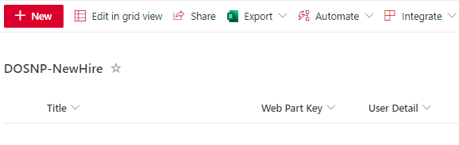

* A new panel will be opened as below.

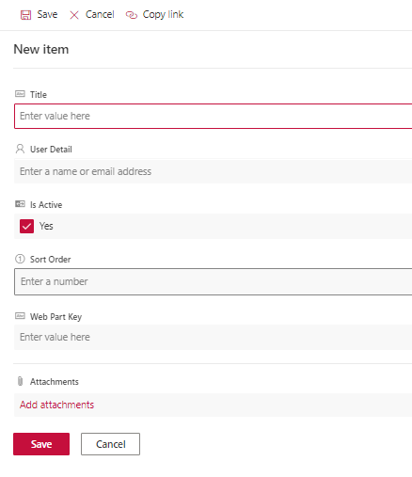

* Enter **Title**, **User Details** values.
* Select **Is Active** to display the item. Else item won’t be displayed.
* Enter sort order to sort items.
* Enter web part key. **Make sure to configure this value in web part properties.**

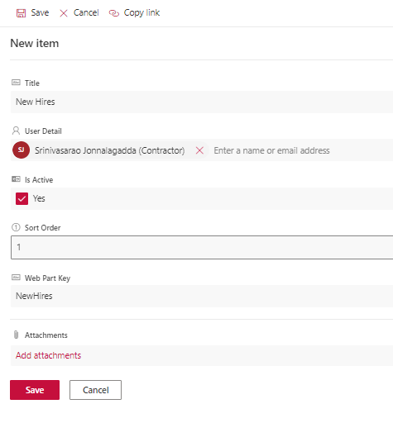

* Click on Save button.
* Item details will be saved into the list.

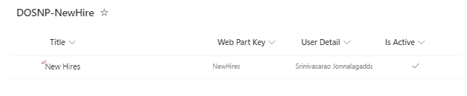

#### Retrieve data from list

* Edit the web part, web part property panel will be opened.
* Select Data source as List and enter web part key value and click on Next button.

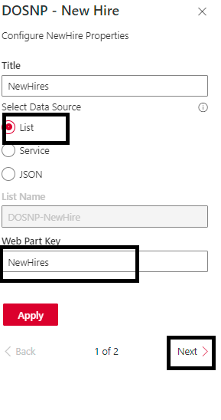

* Select the other properties as shown below based on the requirement.

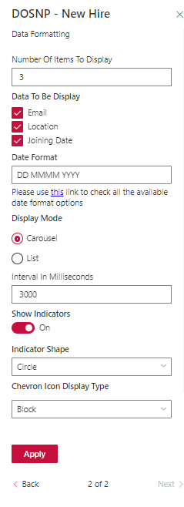

* Enter Number of Items To Display in New Hires.
* Select Email checkbox if email id needs to be displayed.
* Select Location checkbox if location need to be displayed.
* Select Joining Date checkbox if joining date need to be displayed.
* Select Display Mode as Carousel if new hire items need to be displayed as Carousel.
* Select Display Mode as List if new hire items need to be displayed as a List.
* Configure Date Format, Interval in Milliseconds, Show Indicators, Chevron Icon Display Type properties shown above.
* Click on Apply button as shown below.

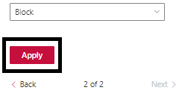

* Save and publish the page.
* Items from DOSNP-NewHire list with web part key mentioned above will start appearing in the web part as shown below.
* New Hire web part If display mode as Carousel.

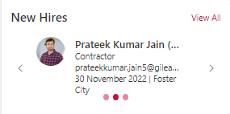

* New Hire web part If display mode as List.



#### Configure using Service

* Edit the web part, web part property panel will be opened.
* Select Data source as Service.

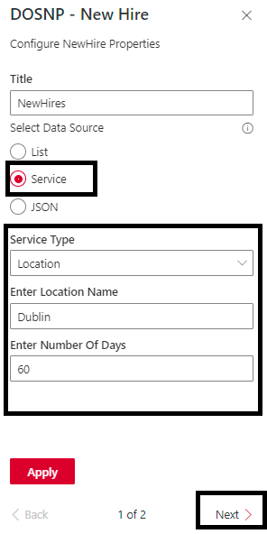

* Select Service Type as Location to display new hires from a location.
* Enter Location Name Ex: Dublin.
* Enter Number of Days to get new hires from last 60 days.
* Configure other properties as explained in the above section (Configure from List).
* Click on Apply button.
* Save and publish the page.

#### Configure using JSON

* Edit the web part, web part property panel will be opened.
* Select Data source as JSON and enter JSON file path.

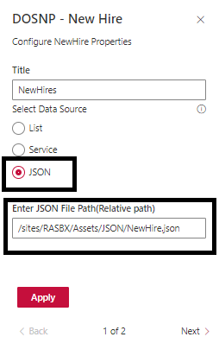

* Configure other properties as explained in the above section (Configure from List).
* Click on apply button.
* Save and publish the page.
* Sample JSON file text.

[{"EmployeeID":3552,"CerID":151638,"Status":"I","Site":"Foster City","locn_dscr":"Foster City","Email":"Terri.Michel@gilead.com","FirstName":"Terri","LastName":"Michel","FullName":"Terri Michel","NTName":"tmichel","Title":"Sr Manager, Development Business Ops","Type":"Regular","ReportsTo":235673,"ManagerCerID":235673,"ManagerID":235673,"ManagerFirstName":"Rachel","ManagerLastName":"Sievert","ManagerFullName":"Rachel Sievert","ManagerEmail":"rachel.sievert@gilead.com","DeptNum":"0011206001","Dept":"Development Business Ops - FC","JobGrade":29,"StartDate":"2001-09-17T00:00:00","LeaveDate":"2020-08-03T00:00:00","BuildingNum":"FC100-1","Phone":"+1 (650) 522-5248","TempAgency":null,"legal_entity":"001","locn_code":"US001","cost_center":"1206","cost_center_descr":"Development Business Ops","lastupdated":"2021-08-03T04:00:00","createdate":"2017-02-08T00:12:00"},{"EmployeeID":14847,"CerID":159150,"Status":"A","Site":"Seattle","locn_dscr":"Seattle","Email":"Deirdre.Mourey@gilead.com","FirstName":"Deirdre","LastName":"Mourey","FullName":"Deirdre Mourey","NTName":"dmourey","Title":"Development Business Ops Assoc II","Type":"Regular","ReportsTo":204219,"ManagerCerID":204219,"ManagerID":27308,"ManagerFirstName":"Amy","ManagerLastName":"McGuire","ManagerFullName":"Amy McGuire","ManagerEmail":"Amy.McGuire@gilead.com","DeptNum":"0011206003","Dept":"Development Business Ops - SE","JobGrade":26,"StartDate":"2006-08-14T00:00:00","LeaveDate":null,"BuildingNum":"ST199-1","Phone":"+1 (206) 832-2026","TempAgency":null,"legal_entity":"001","locn_code":"US004","cost_center":"1206","cost_center_descr":"Development Business Ops","lastupdated":"2021-08-03T04:00:00","createdate":"2017-02-08T00:12:00"}]

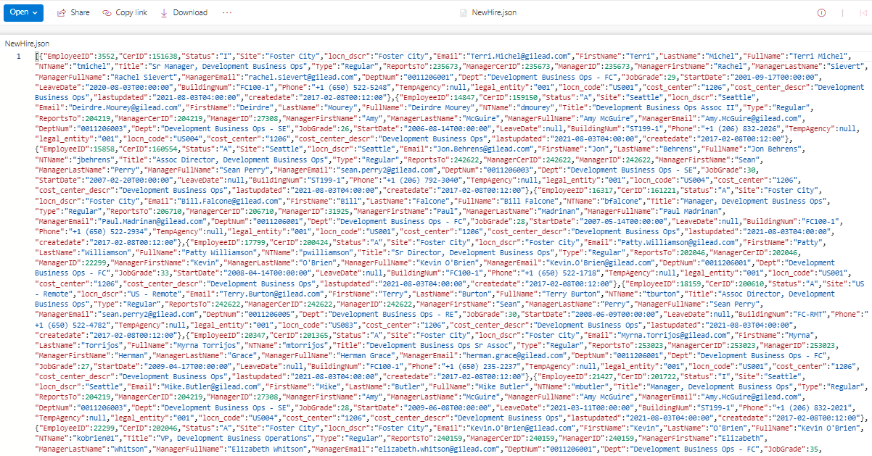

# DOSNP - Notice Board

## Prerequisites

Configure below web part tasks using **DOSNP - Dashboard** web part. Please refer **Configure Web Part Tasks** section in DOSNP - Dashboard web part.

1. Create Fields
2. Create Content Type
3. Create List with Content Type

## Properties

|  |  |  |  |
| --- | --- | --- | --- |
| Webpart Properties | Description | Values/Specifications | Comments |
| Title | Specifies the web part title | Any string value | Title value will be displayed as a web part heading. If there is no title specified, then there is no heading. |
| List Name | Specify list name to retrieve items from a list | Default value is **‘DOSNP-NoticeBoard’** | This is a read only field |
| Web Part Key | Specify web part key to retrieve filtered images from a List | * Default value is **‘Home_NoticeBoard’** | Applicable only if the data source is a **List** |
| Show Notices for (days) | Specify to retrieve notice from past days | Integer value |  |
| Show View All Link | Enables or disables view all link | * True * False | Default value is True |
| Select View All Type | Specify to display view all link type | * Panel * Page | Default value is Panel |
| Page URL | Specify page URL to open view all link in a new page |  | Once view all links is clicked, it redirects to a new page. |
| Enable Subscription | Enables or Disables subscription | * True * False | Default value is True |
| Enable Add Notification | Enables or Disables add notification | * True * False | Default value is True |
| Number Of Items To Display | Specify the item limit display the items | Integer value |  |
| Display Mode | Specify to display items in a selected layout | * List * Carousel | * Select List to display Items in List Mode. * Select Carousel to display Items in Carousel Mode. |

## Configure DOSNP - Notice Board

#### Add data to list

* Navigate to DOSNP-NoticeBoard list (refer how to navigate to a list).
* A new page will be opened as below. Click on New button.

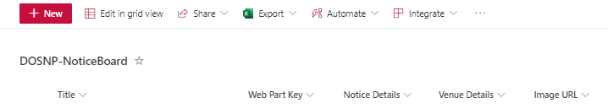

* A new panel will be opened as below.

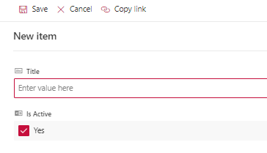

* Enter Title.
* Select Is Active to display the item. Else item won’t be displayed.
* Enter web part key. Make sure to configure this value in web part properties.
* Enter Venue Details, Image URL, Event Start Date, Event End Date, Notice Details.

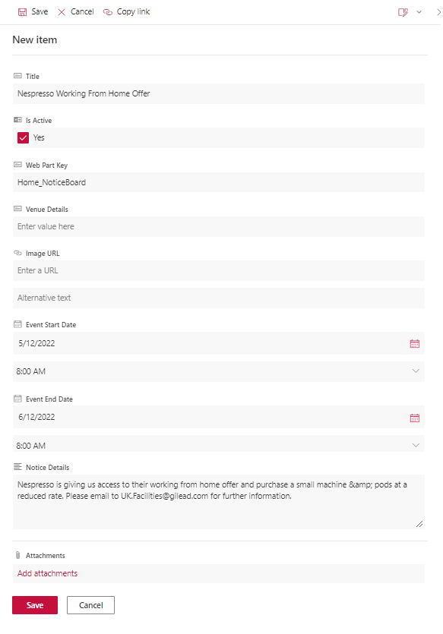

* Click on Save button.
* Item details will be saved into the list.

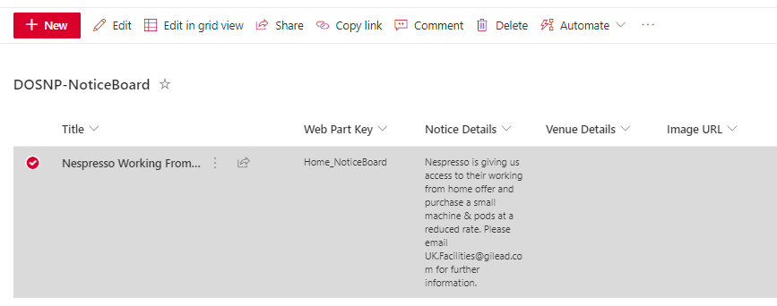

#### Retrieve data from list

* Edit the site page and add DOSNP - NoticeBoard web part to the page.
* Edit the web part, web part property panel will be opened.
* Configure the properties as shown below and click on Next button.

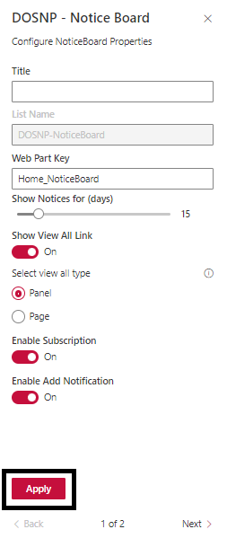

* Enter Web Part Key value. List items with above web part key from DOSNP-NoticeBoard list will be displayed.
* Select display mode as List if items need to be to be displayed as list.
* Select display mode as Carousel if items need to be displayed s carousel.

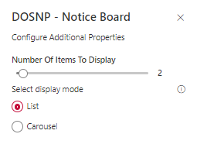

* Select view all type as Panel if you want view all need to open in a panel.
* Select view all type as Page if you want view all need to open in a new page. In the new view all page, configure the same web part with Show View All Link as disabled.
* Click on Apply button.
* Save and publish the page.
* DOSNP - Notice Board web part will be displayed as below.
* If display mode is List.

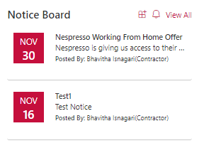

* If display mode is Carousel.

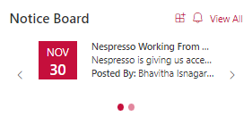

# DOSNP - Featured Links

## Prerequisites

Configure below web part tasks using **DOSNP - Dashboard** web part. Please refer **Configure Web Part Tasks** section in DOSNP - Dashboard web part.

1. Create Fields
2. Create Content Type
3. Create List with Content Type

## Properties

|  |  |  |  |
| --- | --- | --- | --- |
| Webpart Properties | Description | Values/Specifications | Comments |
| Webpart Title | Specifies the web part title | Any string value | Webpart Title value will be displayed as a web part heading. If there is no title specified, then there is no heading. |
| Select Data Source | Select the data source to display featured links | * List * Properties * Termstore | Featured links can be displayed from any selected data source |
| List Name | Specify list name to retrieve items from a list | Default value is DOSNP-FeaturedLinks | This is a read only field |
| Get data from other site | Specifies to get data from other site | * True * False |  |
| Site URL | Specify the required site URL |  |  |
| Web Part Key | Specify web part key to retrieve filtered featured links from List | Any string value | Applicable only if the data source is a **List** |
| Get Webpart key from parameter | Specifies to get webpart key from parameter | * True * False |  |
| Enable Target Audience | Specify if target audience needs to be enabled | * True * False |  |
| Type of audience target | Specify target audience type | * Security Group * Office Location | Target Audience can be enabled based on Security group or office location. |
| Security Group Details (separated by semicolon) | Name of the groups that needs to be targeted |  | Separated by semicolon |
| Location Details (separated by semicolon) | Name of the location that needs to be targeted |  | Separated by semicolon |
| Send Dynamic Data | Specifies to send dynamic data | * True * False |  |
| Open Link in Panel | Specifies to open link in panel | * True * False |  |
| Panel Size | Specifies the panel size | * Small * Medium * Large | Default size is Medium |
| Featured Links Data | Specifies the featured links from properties |  |  |
| Term Set Id | Specify a path to display images from Library | Any library path or folder path | Applicable only if the data source is **Library** |
| Term Id | Specify all image items details to display items from properties | Provide all the item details | Applicable only if the data source is **Properties** |
| Webpart width | Specifies the webpart width | Any Integer value |  |
| Display Format | Specify the item display format | * List * Tile | * Select List to display Items in List Format. * Select Tile to display Items in Tile Format. |
| Include Following Details | Specify to display selected data description | Select description checkbox to display item description |  |
| Show Full Description | Specify to show complete description | * True * False | Default value is False |
| Layout | Specify layout to display the Item | * List * Filmstrip * Thumbnail View * Card View |  |
| Height of the tiles in px | Specifies the height of the tile |  |  |
| Width of the tiles in px | Specifies the width of the tile |  |  |
| Link/Button Label | Specifies to display item label | Any String Value | Visible only when Thumbnail View Layout is selected |
| Card View Width in px | Specifies the width of the card | Any Integer Value | Visible only when Card View Layout is selected |
| Show Image/Icon | Specify to show images/icon before items | * True * False |  |
| Icon Size | Specifies Icon size to display Icon | * Large * Medium * Small * Very Small | Default value is Large |
| Show Heading | Specify to show web part heading | * True * False | Width will be auto, and height can be specified |
| Show Heading Icon | Displays icon before web part heading | * True * False |  |
| Animation Type | Specify animation type to display when tile format is used | * Flip * Slide * None | Default value is Flip |

## Configure DOSNP - Featured Links

Edit the site page and add **DOSNP - Featured Links** web part to the page. This can be configured using 3 different data sources

* List
* Properties
* Termstore

#### Configure using List

#### Add data to list

* Navigate to DOSNP-FeaturedLinks list (refer how to navigate to a list).
* A new page will be opened as below. Click on **New** button.
* A new panel will be opened as below.

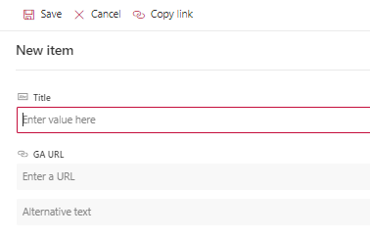

* Enter **Title**, **Description** **Plain, Icon Name** values.
* Enter **GA URL** to open a link when click on an item.
* Select **Open In New Tab** to open a link in new tab.
* Select **Is Active** to display the item. Else item won’t be displayed.
* Enter sort order to sort items.
* Enter web part key. **Make sure to configure this value in web part properties.**

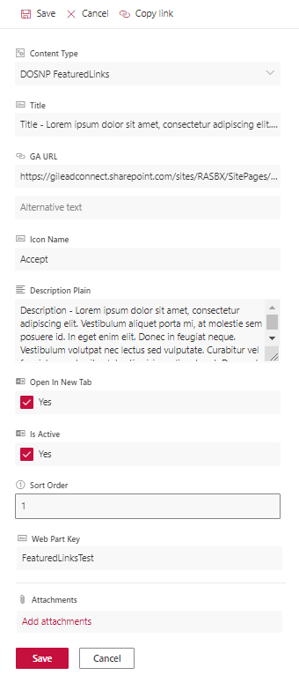

* Click on Save button.
* Item details will be saved into the list.

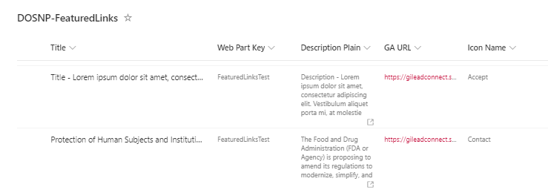

#### Retrieve data from list

* Edit the web part, web part property panel will be opened.
* Select data source as List.
* Enter Web Part Key value to display items from DOSNP-FeaturedLinks list.

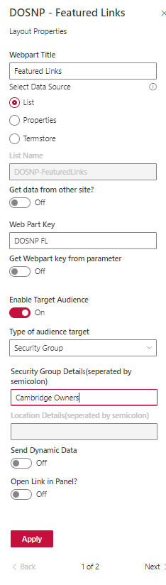

* Enable Target audience if required.
* Select Type of audience target as Security Group to manage target audience based on groups.
* Select Type of audience target as Office location to manage target audience based on location.
* Enter Security Group details. Add multiple groups by separating by semicolon.
* Enter Location Details. Add multiple locations by separating by semicolon.
* Click on next button as shown above.
* Select display format as List to display items as list.
* Select display format as Title to display items as tiles.
* Check Description check box to display item with description. If not checked only item title will be displayed.
* Enable Show Full Description to display complete description. If not, description will be trimmed and only 30 characters will be displayed.
* Select layout as List to display items as list.
* Select layout as Filmstrip to display multiple items in a row.
* Select layout as Thumbnail to display multiple items in a sequence.
* Select layout as Card View to display items in a card format.
* If the display format is Tile, enter height and width of the tile.
* Select Show Image/Icon to display icon before the item.
* Select Show Heading to display web part title.
* Select Show Heading Icon to display header icon.
* Select Animation Type to display the tile items. Default Animation Type is selected as Flip.

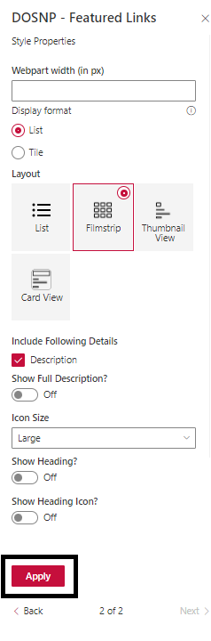

* Click on Apply button.
* DOSNP - Featured Links web part will be displayed as shown below.
* Display format as List and Layout as List without description.

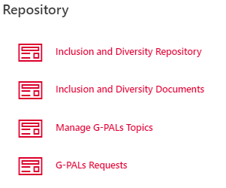

* Display format as list and Layout as List with description.

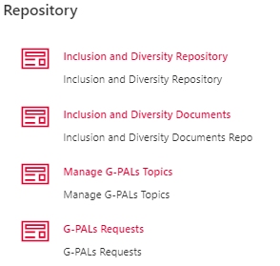

* Display format as list and Layout as Filmstrip.

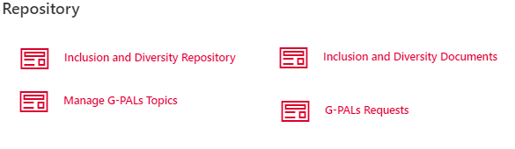

* Display format as list and Layout as Thumbnail.

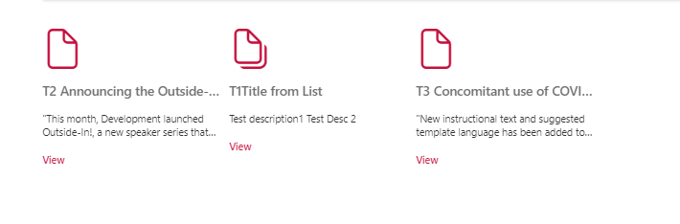

* Display format as list and Layout as Card View.

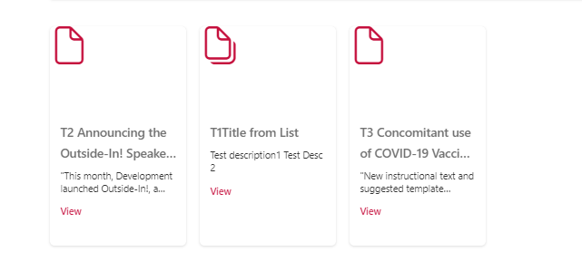

* Display format as Tile.

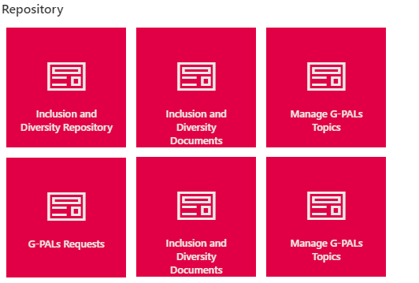

#### Configure using Properties

* Edit the web part, web part property panel will be opened.
* Select data source as Properties and click on configure featured links data button.
* A new property panel will be opened as shown below.

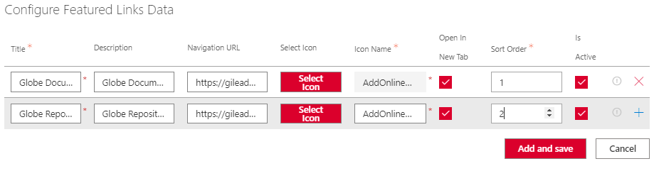

* Enter Title, Description, Navigation URL.
* Click on Select Icon button to select preferable icon.

* Select or search icon from the panel and click on Save button.

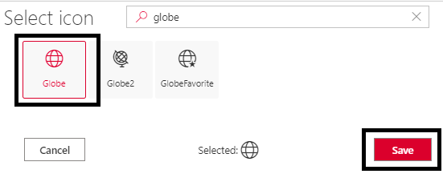

* Select or search icon from the panel.
* Click on + plus icon button to add a new row.

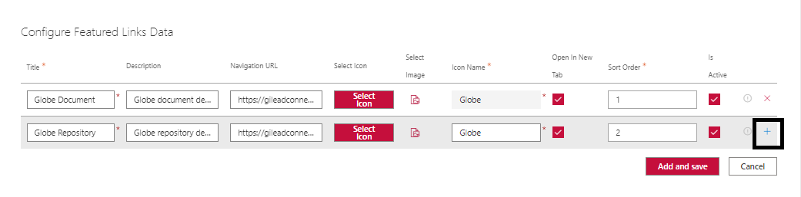

* A new row will be added as shown below.

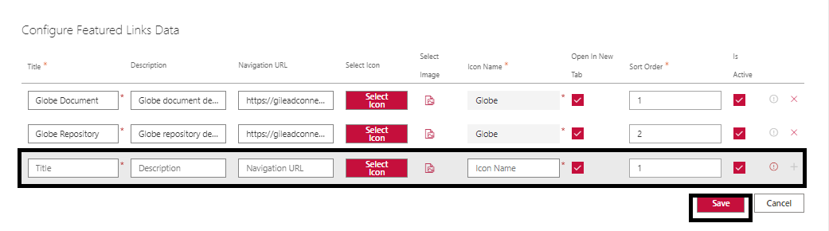

* Click on Save button.
* Configure other properties by referring the above configuring from list section.
* Click o Apply button.

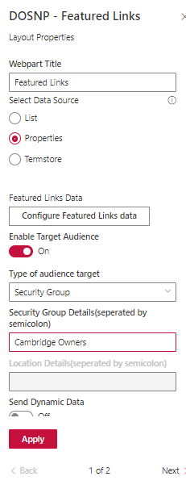

* Save and publish the page.

#### Configure using Termstore

* Edit the web part, web part property panel will be opened.
* Select data source as Termstore.
* Enter Term Set Id and Term Id value.
* Get the Term Set Id value from Site Contents→ Site Settings→ Termstore management.



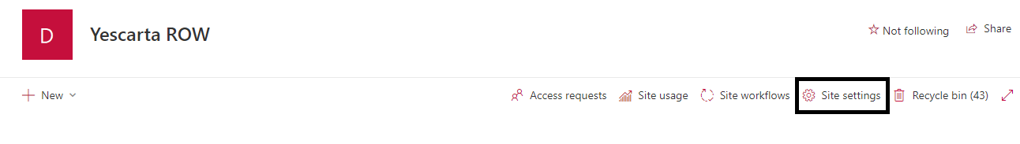

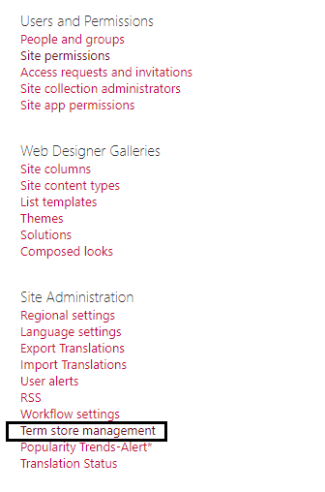

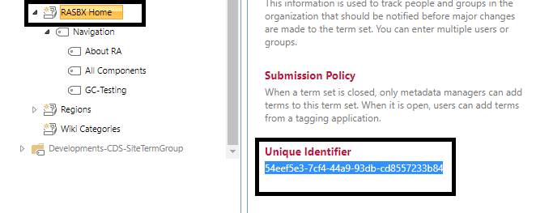

* Get the Term Id value from Site Contents→ Site Settings→ Termstore management.

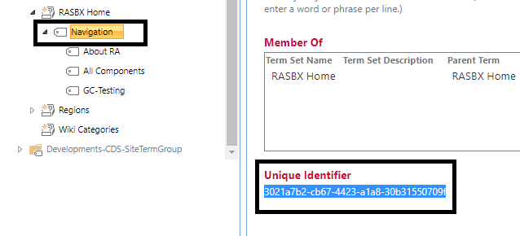

* Configure other web part properties as mentioned in the above configure from list section.
* Click on apply button.

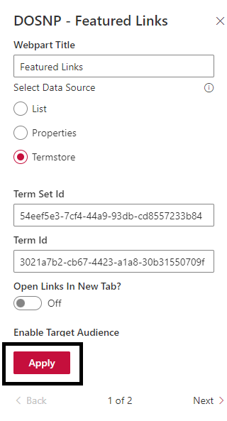

* Save and publish the page.

# DOSNP - Breadcrumb

## Prerequisites

Configure below web part tasks using **DOSNP - Dashboard** web part. Please refer **Configure Web Part Tasks** section in DOSNP - Dashboard web part.

1. Add Configurations

## Properties

|  |  |  |  |
| --- | --- | --- | --- |
| Webpart Properties | Description | Values/Specifications | Comments |
| Title | Specifies the web part title | Any string value | Title value will be displayed as a web part heading. If there is no title specified, then there is no heading. |
| Maximum Number Of Items To Display | Specifies maximum number of breadcrumbs to display before coalescing. If not specified, all breadcrumbs will be rendered. | Any integer value | Default value is 5 |
| Overflow Index | Optional index where overflow items will be collapsed. | Any integer value |  |

## Configure DOSNP - Breadcrumb

#### Edit Configurations

* Navigate to DOSNP-Configurations list and identify DOSNP - Breadcrumb entries as shown below.

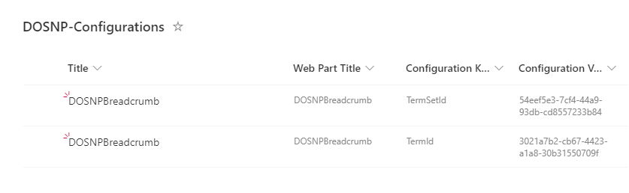

* Select and edit item with configuration key as TermSetId and update configuration value with TermSetId and Save.

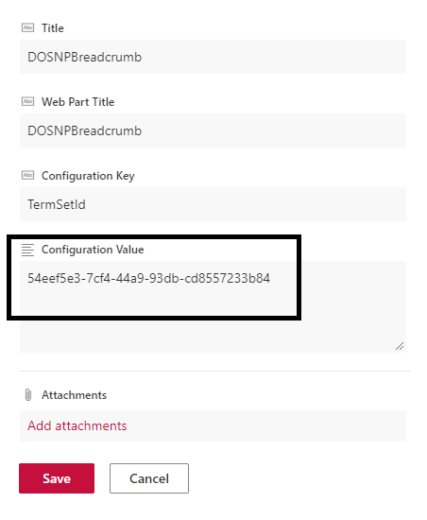

* Select and edit item with configuration key as TermId and update configuration value with TermId and save.

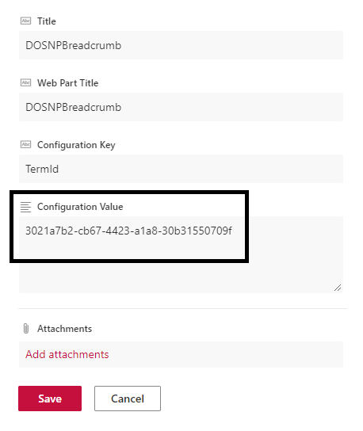

#### Edit Properties

* Edit the site page and add DOSNP - Breadcrumb web part to the page.
* Edit the web part, web part property panel will be opened.
* Enter Title value.
* Enter Maximum Number Of Items To Display value. This specifies maximum number of breadcrumbs to display before coalescing. If not specified, all breadcrumbs will be rendered.
* Enter Overflow Index value. Optional index where overflow items will be collapsed. Default value is 0.

* Click on apply button.
* Breadcrumb will be configured as shown below.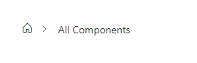

# DOSNP - Navigation

## prerequisites

Configure below web part tasks using **DOSNP - Dashboard** web part. Please refer **Configure Web Part Tasks** section in DOSNP - Dashboard web part.

1. Add Configurations

## Properties

|  |  |  |  |
| --- | --- | --- | --- |
| Webpart Properties | Description | Values/Specifications | Comments |
| Title | Specifies the web part title | Any string value | Title value will be displayed as a web part heading. If there is no title specified, then there is no heading. |
| Select Navigation | Select the navigation type | * Paged * Complete | * Select Navigation as Paged to display navigation under current page. * Select Navigation as Complete to display complete navigation. |
| Number of Levels | Specify the number of levels in the navigation | Any integer value | This limit/display number of levels in the navigation. |
| Show Icons | Display arrow icons before navigational item | * True * False | Default value is **True** |
| Term Set Id | Display navigation from specific term set id | GUID | Configured term navigation will be displayed irrespective of configuration entries in the configuration list. |
| Term Id | Display navigation from specific term Id | GUID | Configured term navigation will be displayed irrespective of configuration entries in the configuration list. |

## Configure DOSNP - Navigation

#### Edit Configurations

* Navigate to DOSNP-Configurations list and identify **DOSNP - Navigation** entries as shown below.

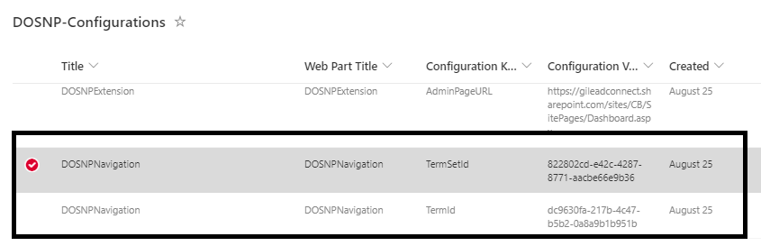

* Select and edit item with configuration key as TermSetId.

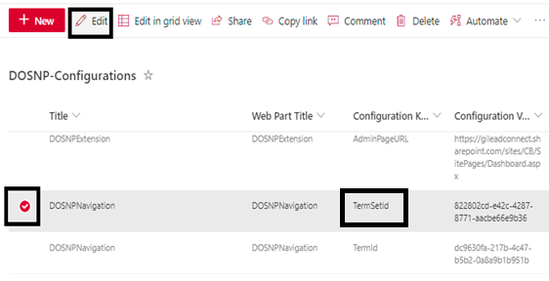

* Enter TermSetId value and Save.

* Select and edit item with configuration key as **TermId** and update the configuration value with TermId value and save it by repeating above steps.

#### Edit Web Part Properties

* Edit web part, web part property panel will be opened.
* Enter **Title** value.
* **Select Navigation** as **Paged** to display navigation under current page.
* **Select Navigation** as **Complete** to display complete navigation.
* Enter **Number of Levels** value to limit/display number of levels in the navigation.
* Enable **Show Icons** to display arrow icons before navigational item.
* Enter **Term Set Id** to display navigation from specific term set id. If this value is entered, navigation will be displayed irrespective of configuration entries in the configuration list.
* Enter **Term Id** to display navigation from specific term id. If this value is entered, navigation will be displayed irrespective of configuration entries in the configuration list.

* Click on apply button.
* Navigation will be configured as shown below.
* In Teams.aspx page with Paged navigation.

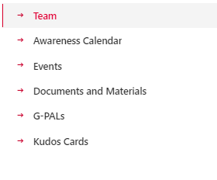

* In Teams.aspx page with Complete navigation.

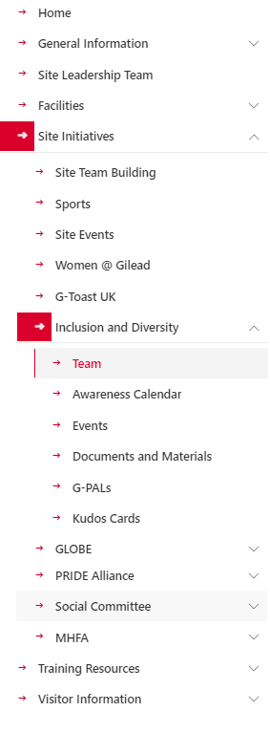

# DOSNP - Accordion

## Prerequisites

Configure below web part tasks using **DOSNP - Dashboard** web part. Please refer **Configure Web Part Tasks** section in DOSNP - Dashboard web part.

1. Create Fields
2. Create Content Type
3. Create List with Content Type

## Properties

|  |  |  |  |
| --- | --- | --- | --- |
| Webpart Properties | Description | Values/Specifications | Comments |
| Title | Specifies the web part title | Any string value | Title value will be displayed as a web part heading. If there is no title specified, then there is no heading. |
| Select Data Source | Select the data source to display items | * List * Properties | Accordion items can be displayed from any selected data source |
| List Name | Specify list name to retrieve accordion items from a list | Default value is ‘**DOSNP-Accordion’** | This is a read only field and applicable only if the data source is **List** |
| Web Part Key | Specify web part key to retrieve filtered items from a List | Any string value | Applicable only if the data source is a **List** |
| Accordion Segregation By | Specify segregation to display the items | * Category * Title | * Select Category to display the items in category group. * Select Title to display the items in title group. |
| Group by Category | Specifies group by category to display the items | * True * False |  |
| Webpart width | Specify width of the webpart |  |  |
| Layout | Select layout to display | * Accordion * Tabs | * Select Accordion to display the items in accordion layout. * Select Tabs to display the items in tabs layout. |
| Item Layout | Select Item Layout display | * List * Filmstrip | * Select List to display the content in item layout. * Select Filmstrip to display the content in item layout. |
| View Type | Select item view type | * All Expanded * All Collapsed * Expand Selected Index | * Select All Expand to display the content in expand mode. * Select Collapsed to display the content in collapsed mode. * Select “Expand Selected Index” to expand a particular section. |
| Data To Be Display | Specify data to display | * Title * Description | * Select the Title checkbox to display the title. * Select the Description checkbox to display the description. |
| Enable Default Icon | Specifies default icon | * True * False | Default value is True |
| Icon Size | Specifies icon size | * Large * Medium * Small * Very Small | Default value is Medium |
| Configure Categories | Specify the list of categories and sort order details |  | Applicable only if the data source is **Properties** |
| Configure Items | Select category and provide item details |  | Applicable only if the data source is **Properties** |

## Configure DOSNP - Accordion

Edit the site page and add DOSNP - Accordion web part to the page. This web part can be configured from two different data sources.

* List
* Properties

#### Configure from List

#### Add data to list

* Navigate to DOSNP-SystemLinks list (refer how to navigate to a list).
* A new page will be opened as below. Click on **New** button.

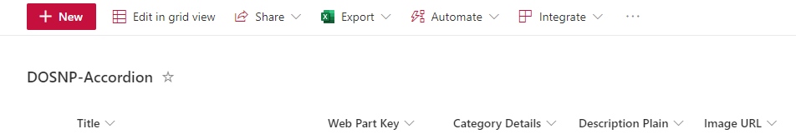

* A new panel will be opened as below.

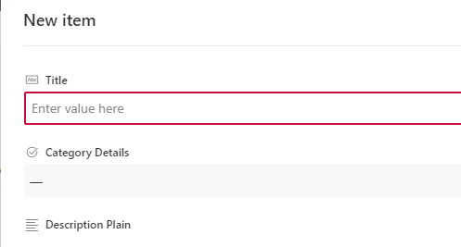

* Enter **Title**, **Description** **Plain** values.
* Select **Category Details.**
* Enter **Image URL**.
* Select **Item Type** as Link.
* Enter **GA URL** to open a link when click on an item.
* Select **Open In New Tab** to open a link in new tab.
* Select **Is Active** to display the item. Else item won’t be displayed.
* Enter sort order to sort items.
* Enter **Icon Name**.
* Enter web part key. **Make sure to configure this value in web part properties.**

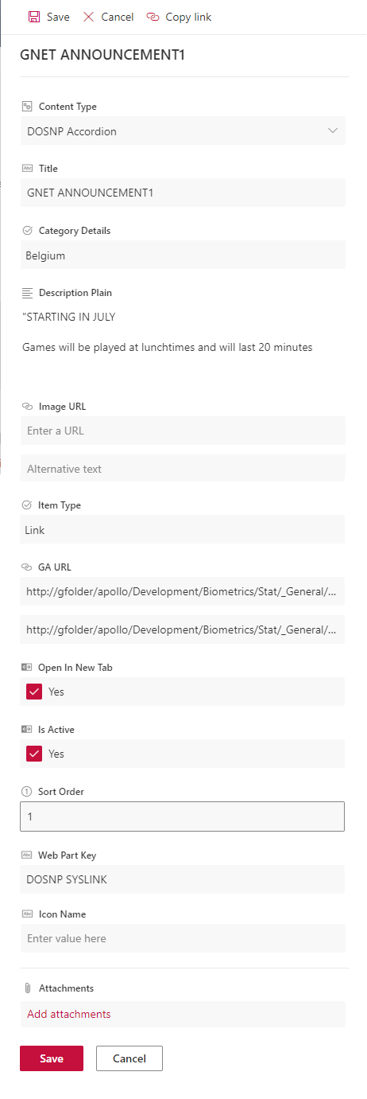

* Click on Save button.
* Item details will be saved into the list.

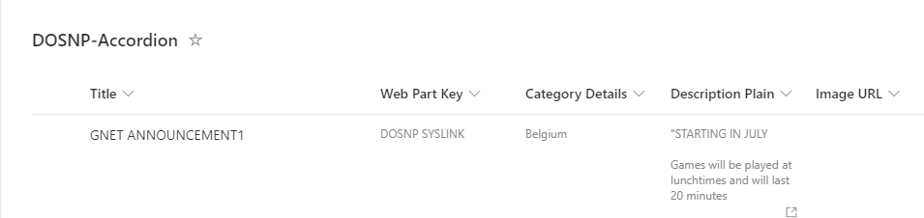

#### Retrieve data from list

* Click on edit web part. Web part property panel will be opened.

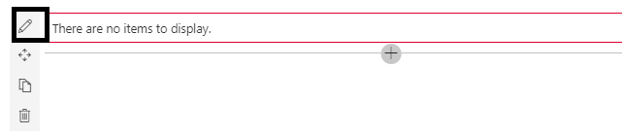

* Enter Title value.
* Select data source as List and enter Web Part Key.
* Select Accordion Segregation By Category to display the content by category.
* Select Accordion Segregation By Title to display the content by title.
* Select Layout and Item Layout to display the items in a layout format.
* Select View Type as All Expanded if accordion sections need to be expanded.
* Select View Type as All Collapsed if accordion sections need to be collapsed.
* Select View Type as Expand Selected Index if a selected accordion section needs to be expanded.

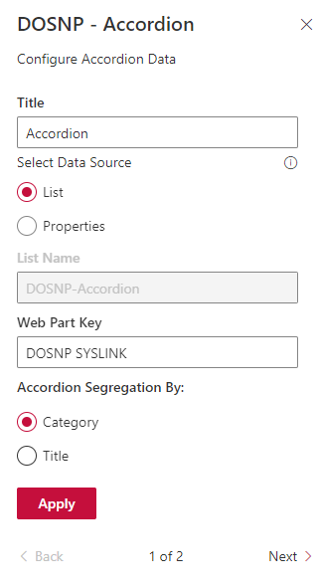

* List items from DOSNP-Accordion list with Web Part Key mentioned above will start appearing in the accordion.
* Save and publish the page.

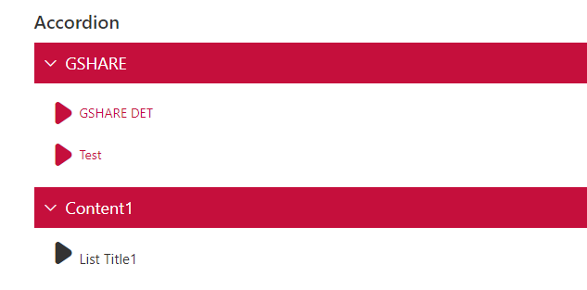

* Display Layout as Accordion and Item Layout as List.

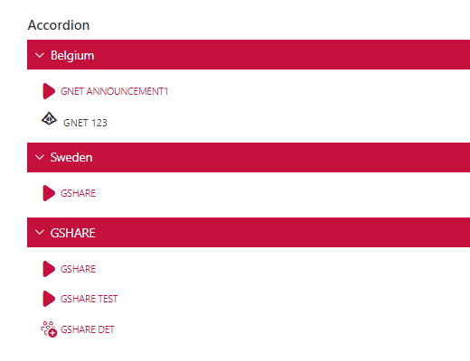

* Display Layout as Accordion and Item Layout as Filmstrip.

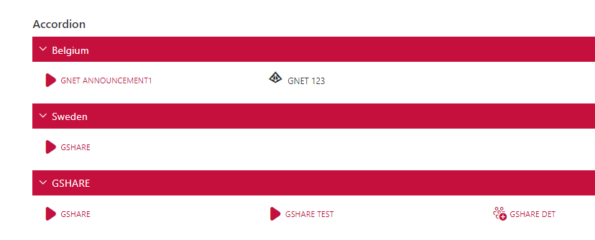

* Display Layout as Tabs and Item Layout as List.

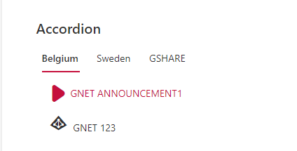

* Display Layout as Tabs and Item Layout as Filmstrip.

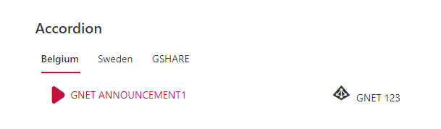

#### Configure from Properties

* Click on edit web part. Web part property panel will be opened.



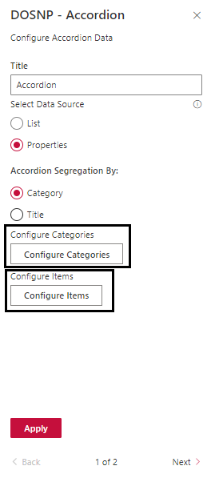

* Select data source as Properties.
* Select Accordion Segregation By Category to display the content by category.
* Select Accordion Segregation By Title to display the content by title.
* Click on Configure Categories button, a new panel will be opened as shown below.
* Enter Category, Sort Order details.
* Click on + icon to add a new row.
* Click on Add and Save button.

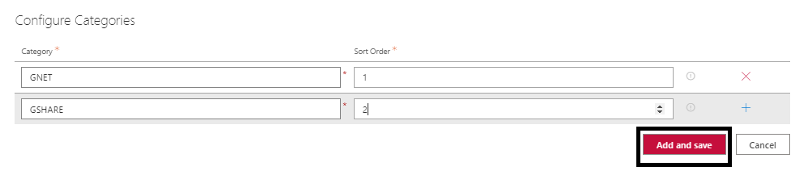

* Click on Configure Category Items, a new panel will be opened as shown below.

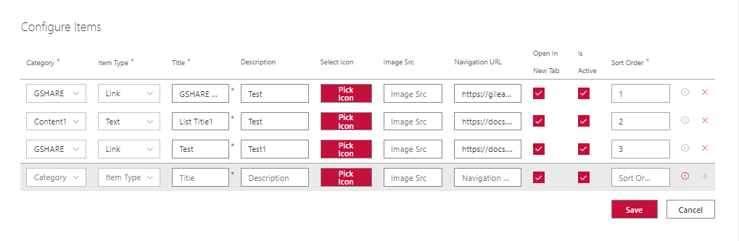

* Select Category, Item Type, Select Icon.
* Enter Title, Description, Navigation URL, Sort Order.
* Make sure Is Active is checked to display the item in accordion, otherwise that item won’t be displayed.
* Make sure Open in New Tab is checked to open then link in new tab.
* To add a new item detail, click on + button as shown below.

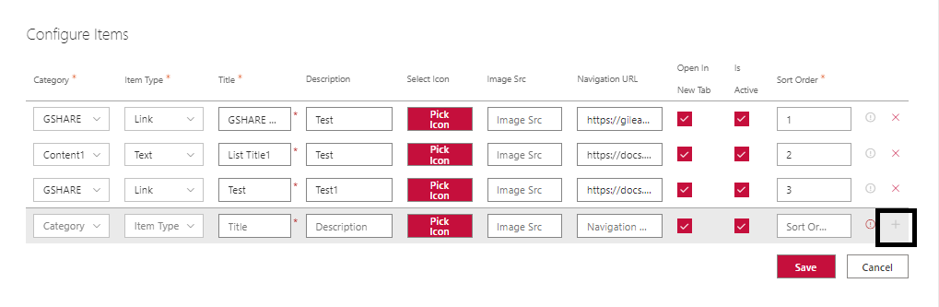

* A new empty row will be added as shown below.

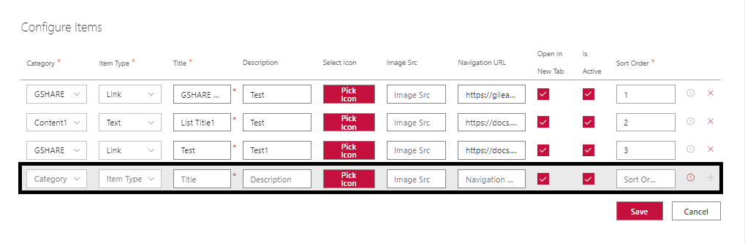

* Enter all the details and click on Save button.
* Click on Apply button.
* Save the page and publish it.

# DOSNP - Document Card

## Prerequisites

Configure below web part tasks using **DOSNP - Dashboard** web part. Please refer **Configure Web Part Tasks** section in DOSNP - Dashboard web part.

1. Create Fields
2. Create Content Type
3. Create List with Content Type

## Properties

|  |  |  |  |
| --- | --- | --- | --- |
| Webpart Properties | Description | Values/Specifications | Comments |
| Title | Specifies the web part title | Any string value | Title value will be displayed as a web part heading. If there is no title specified, then there is no heading. |
| Select Data Source | Select the data source to display carousel images | * List * Library * Properties | Document card items can be displayed from any selected data source |
| List Name | Specify the list name to display document card items | Default value is ‘**DOSNP-DocumentCards**’ | This is a read only field and applicable only if the data source is **List** |
| Web Part Key | Specify web part key to retrieve filtered items from a List | Any string value | Applicable only if the data source is a **List** |
| Show View All Link | Specify view all link to view all the items | * True * False | Default value is False |
| Select View All Type | Specify to display view all link type | * Panel * Page | Default value is Panel |
| Enable Search | Enable search option to search for specific item | * True * False | Default value is False |
| Select Data Fields | Specifies data fields to display the items | * Title * Description * Image Src | * Title is a read only field * Check and Uncheck Description and Image Src data fields |
| Library relative path | Specifies library path to retrieve data from library | Any string value | Applicable only if the data source is **Library** |
| Configure Data | Specify all document card details to display items from properties | Provide all the items details | Applicable only if the data source is **Properties** |
| Layout | Specify layout to display items | * List * Carousel * Filmstrip |  |
| Number Of Items To Display | Specify the item limit to display | Default value is 100 |  |
| Interval In Milliseconds | Specify the amount of time to delay between automatically cycling an item | Default value is 5 seconds |  |
| Pause On Hover | Specifies if slides cycling should pause when hovering over the content | * True * False | Default value is **True** |
| Is Infinite | Indicates if infinite scrolling is enabled | * True * False | Default value is **True** |
| Show Indicators | Specifies if set of slide position indicators is shown | * True * False | Default value is **True** |
| Indicator Shape | Specifies the indicator shape | * Circle * Square * Rectangle | Default value is **Circle** |
| Chevron Icon Display Type | Specifies the buttons container display mode | * Block * Hidden | Default value is **Block** |

## Configure DOSNP - Document Card

Edit the site page and add DOSNP - Document Card web part to the page. This web part can be configured from 2 different data sources.

* List
* Properties

#### Configure from List

#### Add data to list

* Navigate to DOSNP- DocumentCards (refer how to navigate to a list)
* A new page will be opened as below. Click on **New** button.

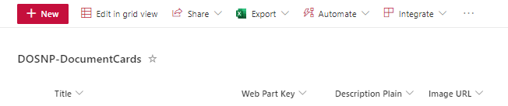

* A new panel will be opened as below.

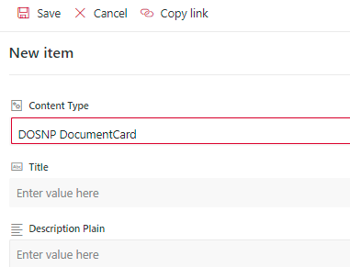

* Enter **Title**, **Description** **Plain** values.
* Enter **Image URL**. This image will be displayed in the carousel.
* Enter **GA URL** to open a link when click on an item.
* Select **Open In New Tab** to open a link in new tab.
* Select **Is Active** to display the item in carousel. Else item won’t be displayed in carousel.
* Enter sort order to sort items.
* Enter web part key. **Make sure to configure this value in web part properties.**

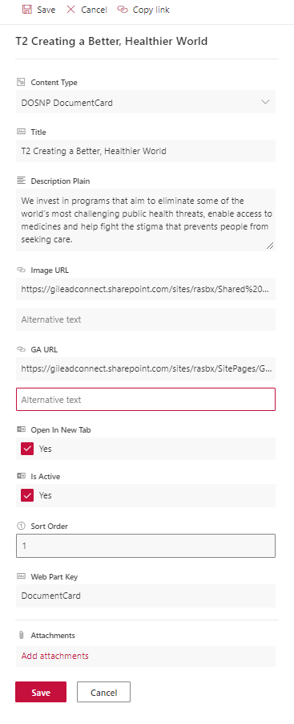

* Click on Save button.
* Item details will be saved into the list.

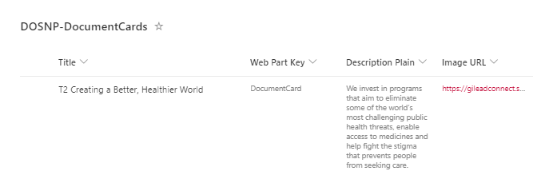

#### Retrieve data from list

* Click on edit web part. Web part property panel will be opened.



* Select data source as List and enter Web Part Key and click on Next button as shown below.

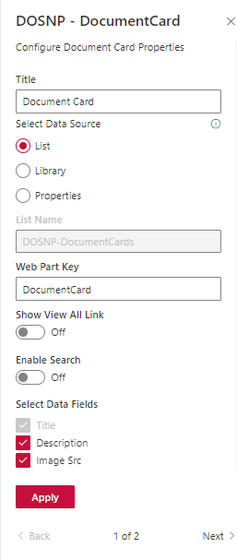

* Configure other web part properties as shown below and click on apply button.

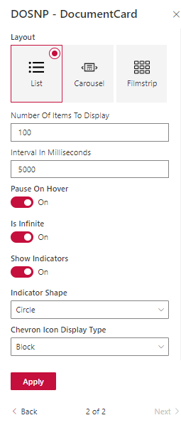

* Items from DOSNP-DocumentCards list with Web Part Key mentioned above will start appearing in the page.
* Save the page and publish the page.
* Display Layout as List.



* Display Layout as Carousel.



* Display Layout as Filmstrip.



#### Configure from Library

* Click on edit web part. Web part property panel will be opened.



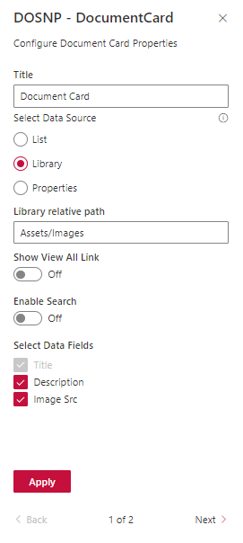

* Select Library as selected data source.
* Enter Library relative path to retrieve data from Library.
* Click on next button and configure other web part properties as shown below.



* Click on Apply button.

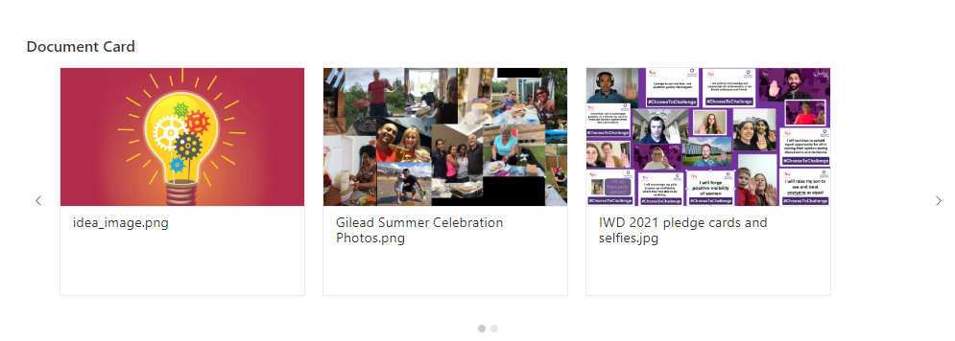

* Items from the Library will start appearing in the page.
* Save and publish the page.

#### Configure from Properties

* Click on edit web part. Web part property panel will be opened.



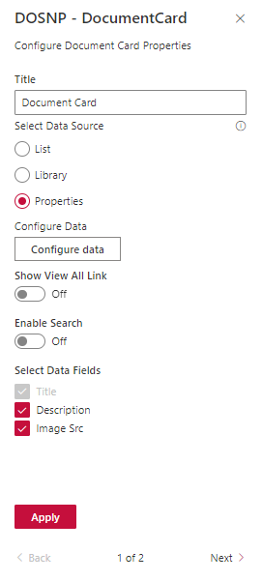

* Select Properties as selected data source.
* Click on Configure Data button. A new panel will be opened.

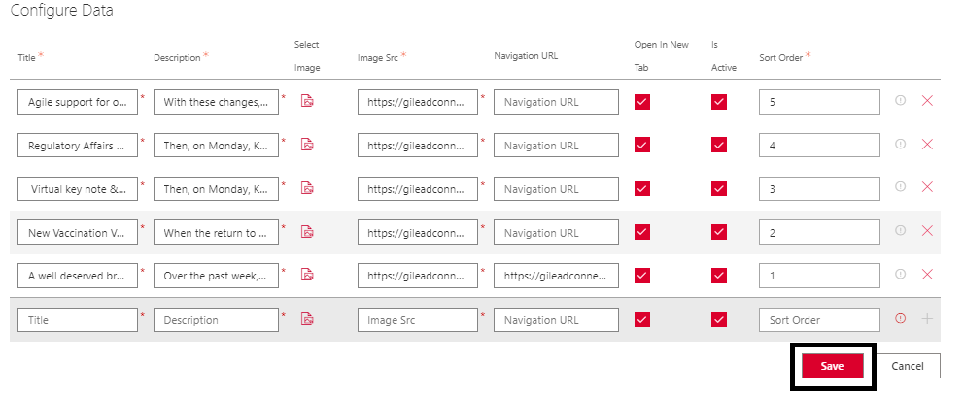

* Enter Title, Description, Navigation URL, Sort Order and select image by clicking on select image button.
* Make sure Is Active is checked to display the item, otherwise that item won’t be displayed.
* Make sure Open in New Tab is checked to open then link in new tab.
* To add a new item detail, click on + button. A new empty row will be added.
* Enter all the details and click on Save button.
* Click on next button and configure the other properties as shown below.



* Click on Apply button.

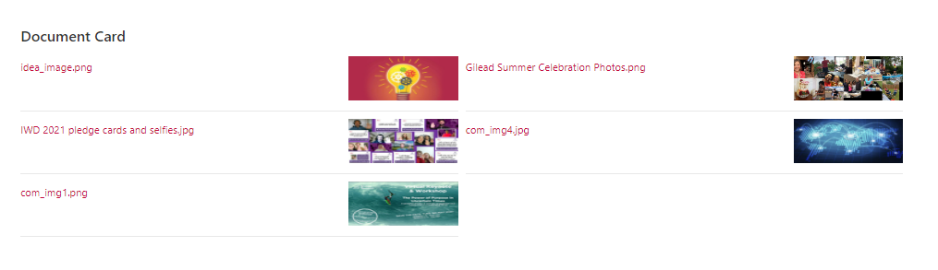

* Save and publish the page.

# DOSNP - Testimonials

## Prerequisites

Configure below web part tasks using **DOSNP - Dashboard** web part. Please refer **Configure Web Part Tasks** section in DOSNP - Dashboard web part.

1. Create Fields
2. Create Content Type
3. Create List with Content Type

## Properties

|  |  |  |  |
| --- | --- | --- | --- |
| Webpart Properties | Description | Values/Specifications | Comments |
| Title | Specifies the web part title | Any string value | Title value will be displayed as a web part heading. If there is no title specified, then there is no heading. |
| Select Data Source | Select the data source to display document card items | * List * Properties | Document card items can be displayed from any selected data source |
| List Name | Specify the list name to display document card items | Default value is ‘**DOSNP-Testimonials**’ | This is a read only field and applicable only if the data source is **List** |
| Web Part Key | Specify web part key to retrieve filtered items from a List |  | Applicable only if the data source is a **List** |
| Configure Data | Specify all document card details to display items from properties | Provide all the items details | Applicable only if the data source is **Properties** |
| Number Of Items To Display | Specify the item limit to display |  |  |
| Number Of Items To Group | Specify the number of cards to group |  | All the items that are grouped will display as single item |
| Interval In Milliseconds | Specify the amount of time to delay between automatically cycling an item | Default value is 5 seconds |  |
| Pause On Hover | Specifies if slides cycling should pause when hovering over the content | * True * False | Default value is **True** |
| Is Infinite | Indicates if infinite scrolling is enabled | * True * False | Default value is **True** |
| Show Indicators | Specifies if set of slide position indicators is shown | * True * False | Default value is **True** |
| Indicator Shape | Specifies the indicator shape | * Circle * Square * Rectangle | Default value is **Circle** |
| Chevron Icon Display Type | Specifies the buttons container display mode | * Block * Hidden | Default value is **Block** |

## Configure DOSNP Testimonials

Edit the site page and add DOSNP - Testimonials web part to the page. This web part can be configured from 2 different data sources.

* List
* Properties

#### Configure from List

#### Add data to list

* Navigate to DOSNP-Testimonials list (refer how to navigate to a list).
* A new page will be opened as below. Click on **New** button.

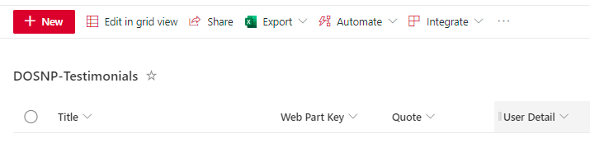

* A new panel will be opened as below.

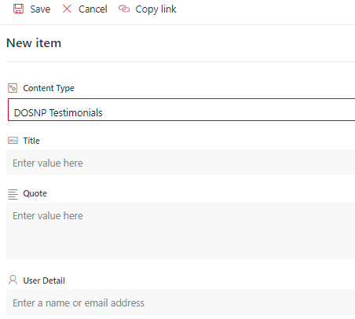

* Enter Title, Quote and User Details values.
* Enter Image URL. This image will be displayed in the carousel.
* Enter GA URL to open a link when click on an item.
* Select Open In New Tab to open a link in new tab.
* Select Is Active to display the item in carousel. Else item won’t be displayed in carousel.
* Enter sort order to sort items.
* Enter web part key. Make sure to configure this value in web part properties.

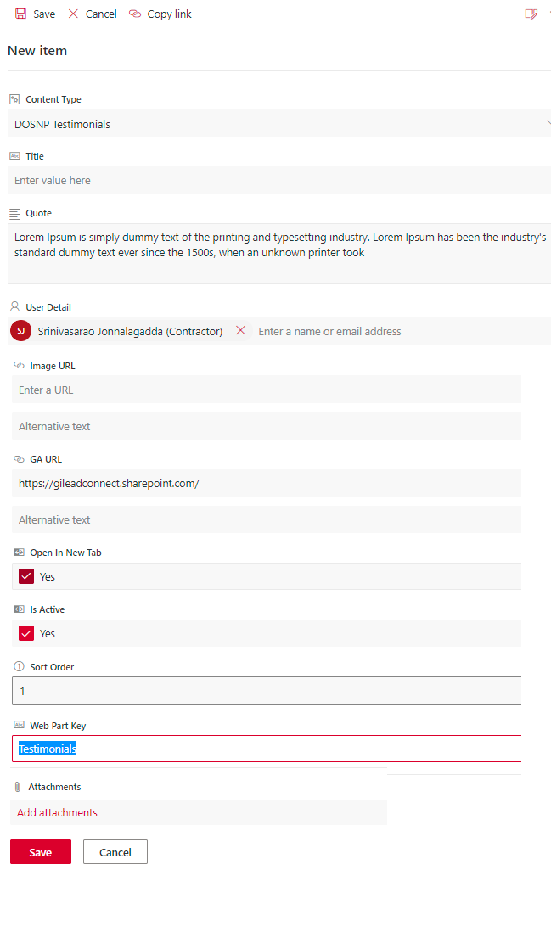

* Click on Save button.
* Item details will be saved into the list.

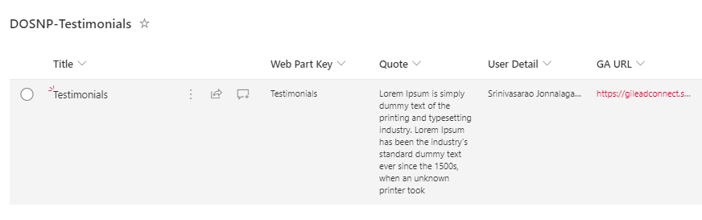

#### Retrieve data from list

* Click on edit web part. Web part property panel will be opened.



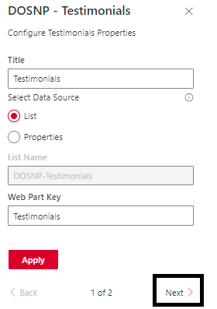

* Select data source as List and enter Web Part Key and click on Next button.
* Configure other web part properties as shown below and click on apply button.

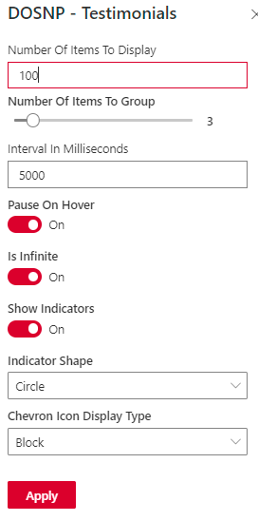

* Items from DOSNP-Testimonials list with Web Part Key mentioned above will start appearing in the page.

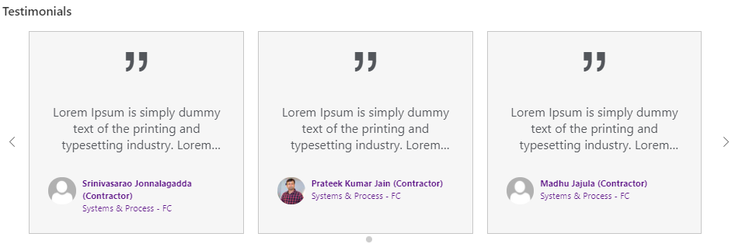

* Save and publish the page.

#### Configure from Properties

* Click on edit web part. Web part property panel will be opened.



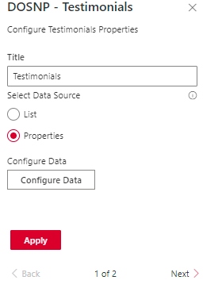

* Select data source as Properties.
* Click on Configure Data button. A new panel will be opened as below.

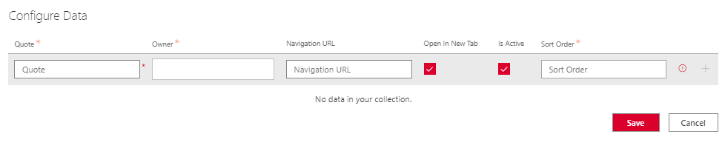

* Enter Quote, Owner, Navigation URL details.
* Make sure Is Active is checked to display the item, otherwise that item won’t be displayed.
* Make sure Open in New Tab is checked to open then link in new tab.
* To add a new item detail, click on + button. A new empty row will be added.
* Enter all the details and click on Save button.
* Click on save button.

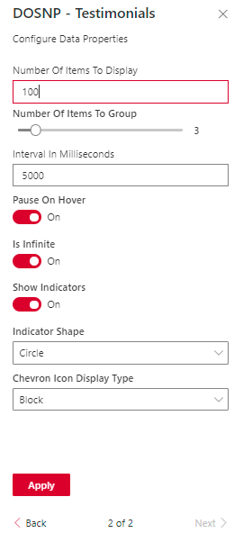

* Items configured from properties will start appearing in the page.

* Save and publish the page.

# DOSNP - Key Contacts

## Prerequisites

Configure below web part tasks using **DOSNP - Dashboard** web part. Please refer **Configure Web Part Tasks** section in DOSNP - Dashboard web part.

1. Create Fields
2. Create Content Type
3. Create List with Content Type

## Properties

|  |  |  |  |
| --- | --- | --- | --- |
| Webpart Properties | Description | Values/Specifications | Comments |
| Webpart Title | Specifies the web part title | Any string value | Title value will be displayed as a web part heading. If there is no title specified, then there is no heading. |
| Select Data Source | Select the data source to display items | * List * Properties | Items can be displayed from any selected data source |
| List Name | Specify list name to retrieve accordion items from a list | Default value is ‘**DOSNP-KeyContacts’** | This is a read only field and applicable only if the data source is **List** |
| Web Part Key | Specify web part key to retrieve filtered items from a List | Any string value | Applicable only if the data source is a **List** |
| View Type | Select accordion display type | * All Expanded * All Collapsed * Expand Selected Index |  |
| Configure Categories | Specify the list of categories and sort order details |  | Applicable only if the data source is **Properties** |
| Configure Data | Select category and provide item details |  | Applicable only if the data source is **Properties** |
| Data to be Displayed | Select required details to display | * Job Title * Department * Role * Contact Details * Email |  |
| Webpart width (in px) | Specifies the width of the webpart | Any Integer value |  |
| Group by Category | Specify items by grouping the category | * True * False | Default value is True |
| Layout | Specifies to display the items in a layout format | * Accordion * Tabs * List * Carousel * Filmstrip |  |

## Configure Key Contacts

Edit the site page and add DOSNP - KeyContacts web part to the page. This web part can be configured from 2 different data sources.

* List
* Properties

#### Configure from List

#### Add data to list

* Navigate to DOSNP-KeyContacts list (refer how to navigate to a list).
* A new page will be opened as below. Click on **New** button.

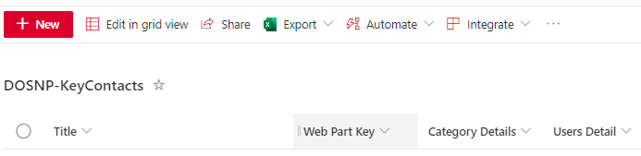

* A new panel will be opened as below.

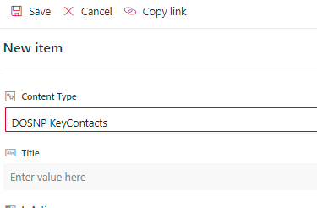

* Enter **Title** and **User Role** values**.**
* Select **Category Details, User Details.**
* Select **Is Active** to display the item in carousel. Else item won’t be displayed in carousel.
* Enter sort order to sort items.
* Enter web part key. **Make sure to configure this value in web part properties.**

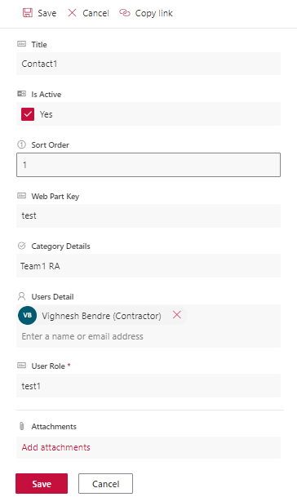

* Click on Save button.
* Item details will be saved into the list.

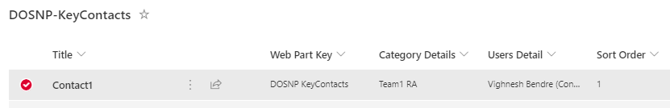

#### Retrieve data from list

* Click on edit web part. Web part property panel will be opened.

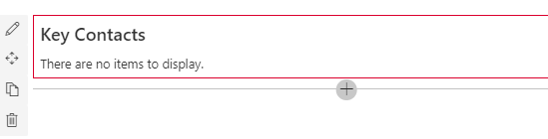

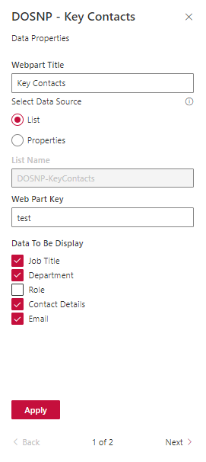

* Select data source as List and enter Web Part Key.
* Select Job Title checkbox to display job title.
* Select Department checkbox to display department name.
* Select Role checkbox to display title.
* Select Contact Details checkbox to display contact information.
* Select Email checkbox to display email id.
* Items from DOSNP-KeyContacts list with Web Part Key mentioned above will start appearing in the page.

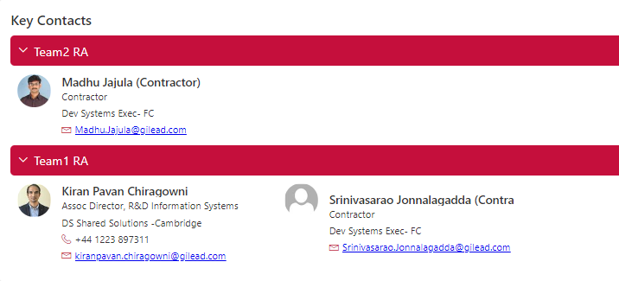

* Configure other web part properties as shown below and click on apply button.

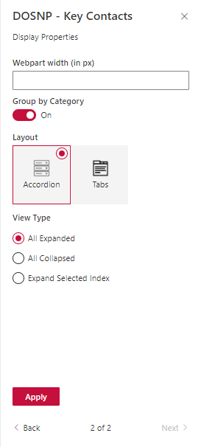

* Save and publish the page.

#### Configure from Properties

* Click on edit web part. Web part property panel will be opened.



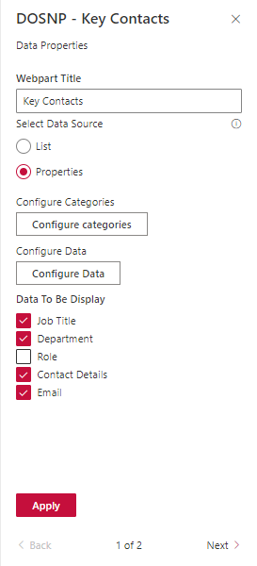

* Select data source as Properties.
* Click on Configure Categories button. A new panel will be opened as below.

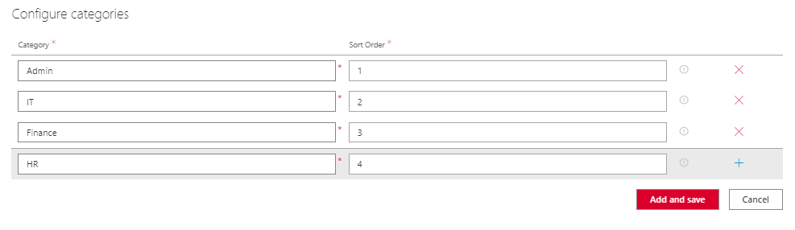

* Enter Category and Sort Order details and click on Add and Save button.
* Click on Configure Data button. A new panel will be opened.

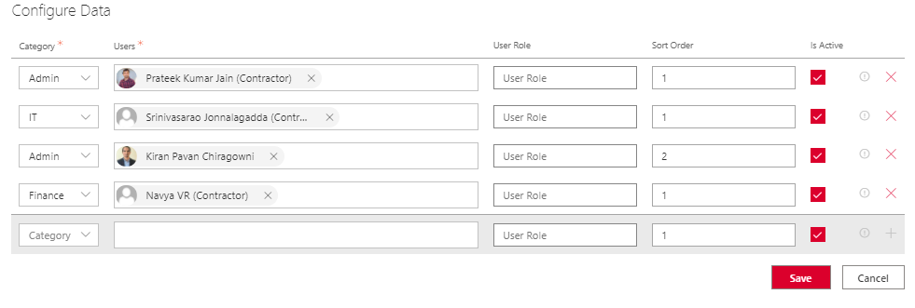

* Select Category, User’s information.
* Enter User Role, Sort Order details.
* Make sure Open in New Tab is checked to open the link in new tab.
* To add a new item detail, click on + button. A new empty row will be added.
* Enter all the details and click on Save button.
* Click on Apply button.
* Items configured from properties will start appearing in the page.

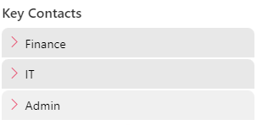

* Save and publish the page.

# DOSNP - Thumbnail Carousel

## Prerequisites

Configure below web part tasks using **DOSNP - Dashboard** web part. Please refer **Configure Web Part Tasks** section in DOSNP - Dashboard web part.

1. Create Fields
2. Create Content Type
3. Create List with Content Type

## Properties

|  |  |  |  |
| --- | --- | --- | --- |
| Webpart Properties | Description | Values/Specifications | Comments |
| Title | Specifies the web part title | Any string value | Title value will be displayed as a web part heading. If there is no title specified, then there is no heading. |
| Select Data Source | Select the data source to display carousel images | * List * Properties | Images can be displayed from any selected data source |
| List Name | Specify the list name to display images | Default value is **‘DOSNP-ThumbnailCarousel’** | This is a read only field and applicable only if the data source is **List** |
| Web Part Key | Specify web part key to retrieve filtered images from a List | Any string value | Applicable only if the data source is a **List** |
| Configure Thumbnail Carousel Data | Specify all image item details to display items from properties | Provide all the item details | Applicable only if the data source is **Properties** |
| Number Of Items To Display | Specify the item limit | Any Integer value |  |
| Webpart width | Specify width of the webpart |  |  |
| Show Print Option | Specify to display print option | * True * False | Default value is false |
| Show Expand Option | Specifies to expand the image | * True * False | Default value is **False** |
| Auto Play | Specifies if slides cycling should pause when hovering over the content | * True * False | Default value is **True** |
| Show Thumbnail | Specify to display thumbnails | * True * False | Default value is **True** |
| Show Arrows | Specifies to display chevron icons | * True * False | Default value is **True** |

## Configure DOSNP - Thumbnail Carousel

Edit the site page and add DOSNP - Thumbnail web part to the page. This web part can be configured from 2 different data sources.

* List
* Properties

#### Configure from List

#### Add data to list

* Navigate to DOSNP-ThumbnailCarousel list (refer how to navigate to a list).
* A new page will be opened as below. Click on **New** button.

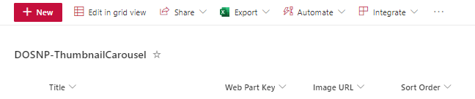

* A new panel will be opened as below.

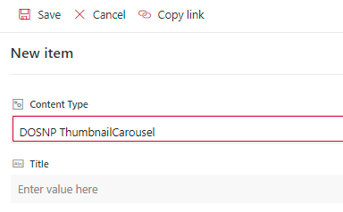

* Enter **Title**, **Description** **Plain** values.
* Enter **Image URL**. This image will be displayed in the carousel.
* Select **Is Active** to display the item in carousel. Else item won’t be displayed in carousel.
* Enter sort order to sort items.
* Enter web part key. **Make sure to configure this value in web part properties.**

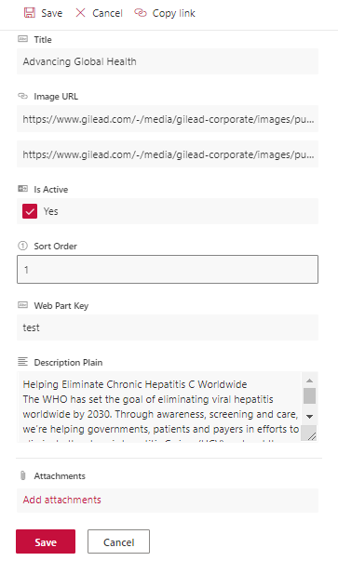

* Click on Save button.
* Item details will be saved into the list.

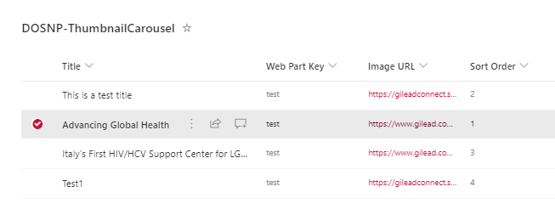

#### Retrieve data from list

* Click on edit web part. Web part property panel will be opened.

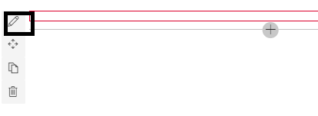

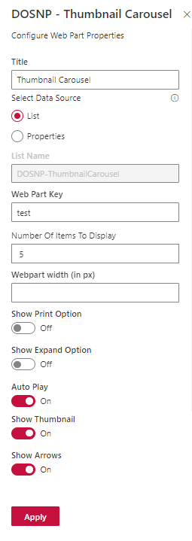

* Enter Title value.
* Select Data source as List.
* Enter web part key value to filter items from DOSNP- ThumbnailCarousel list.
* Enter Number of items to Display value to limit number of items.
* Select Show Print to display print icon.
* Select Show Expand to expand the Image.
* Select Auto Play to slide items automatically.
* Select Thumbnail to show images in thumbnail.
* Select Arrows to show navigation arrows.
* Click on apply button.
* Items from DOSNP-ThumbnailCarousel list with Web Part Key mentioned above will start appearing in the page.



* Save and publish the page.

#### Configure from Properties

* Click on edit web part. Web part property panel will be opened.



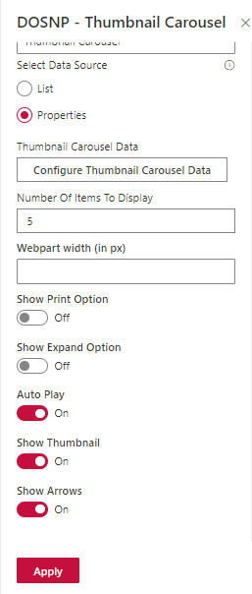

* Enter Title value.
* Select Data source as properties.
* Enter Number of items to Display value to limit number of items.
* Select Show Print to display print icon.
* Select Show Expand to expand the Image.
* Select Auto Play to slide items automatically.
* Select Thumbnail to show images in thumbnail.
* Select Arrows to show navigation arrows.
* Click on configure thumbnail carousel button. A new panel will be opened.

* Enter Title value.
* Enter Description value. This can be text or HTML content.
* Select Image and Sort Order.
* Make sure Open in New Tab is checked to open the link in new tab.
* To add a new item detail, click on + button. A new empty row will be added.
* Enter all the details and click on Save button.
* Click on apply button.
* Items from properties will start appearing in the page.

* Save and publish the page.

# DOSNP - Multi Layout Editor

## Properties

|  |  |  |  |
| --- | --- | --- | --- |
| Webpart Properties | Description | Values/Specifications | Comments |
| Title | Specifies the web part title | Any string value | Title value will be displayed as a web part heading. If there is no title specified, then there is no heading. |
| Layout | Specify the content display mode | * One Column * Two Column | * Select one column to   Display content in one column layout.   * Select two column to display content in two column layout. |
| Title color | Specify the web part title color |  |  |
| Webpart width (in px) | Specifies width of the webpart |  |  |
| Image Alignment | Specify image alignment type | * None * Left * Right | * Select None if no image is required * Select Left to align image to left * Select Right to align image to right |
| Click here to upload image | Specify background image |  | Can upload image from within site or local computer |
| Image Width in % | Specifies width of the image |  |  |
| Align webpart at the center (When used in full width section) | Specify webpart alignment at the center | * True * False | Default value is False |
| Section Background Color | Specify the webpart background color |  |  |

## Configure DOSNP - Multi Layout Editor

Edit the site page and add DOSNP - Multi Layout Editor web part to the page. This web part can be configured in two ways

* One Column
* Two Column

#### One Column Layout

* Edit the web part



* Enter text in the web part

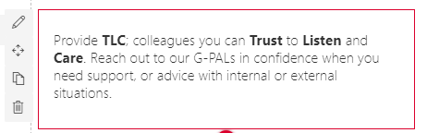

* Edit the web part as shown below. A new web part property panel will be opened.

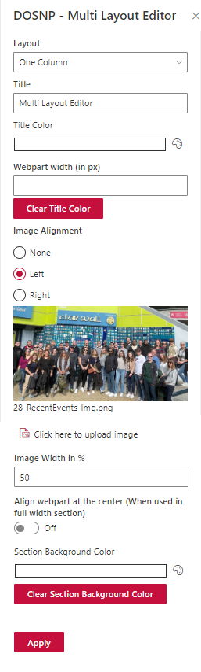

* Select Layout type as One Column.
* Enter Title, Title color and Background Color.
* Select Image alignment.
* Click on “click here to upload image” and select the required image.
* Enter Image Width in percentage.
* Select Align webpart at the center when full width section is used.
* Click on apply button.
* DOSNP Multi layout editor web part with selected single layout will be displayed as below.



* Save and publish the page.

#### Two Column Layout

* Edit the web part as shown below.



* A new property panel will be opened as below.

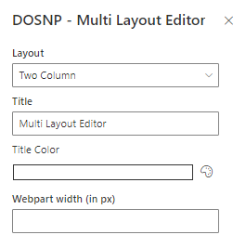

* Select Layout type as Two Column.
* Enter Title and Title color.
* Click on “click here to upload image” and select the required image.
* Select Align webpart at the center when full width section is used.
* Click on apply button.

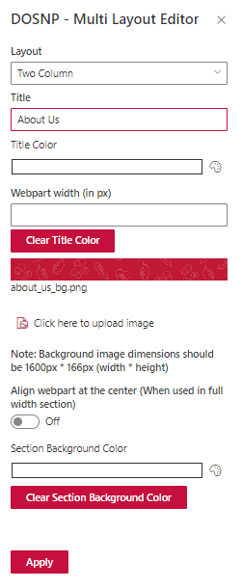

* Enter text in both columns as shown below.

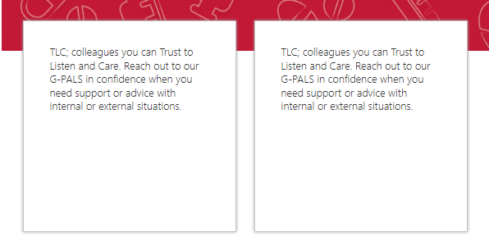

* DOSNP Multi layout editor web part with selected Two column layout will be displayed as below.



* Save and publish the page.

# DOSNP - Render HTML

## Prerequisites

Configure below web part tasks using **DOSNP - Dashboard** web part. Please refer **Configure Web Part Tasks** section in DOSNP - Dashboard web part.

1. Create Fields
2. Create Content Type
3. Create List with Content Type

## Properties

|  |  |  |  |
| --- | --- | --- | --- |
| Webpart Properties | Description | Values/Specifications | Comments |
| Title | Specifies the web part title | Any string value | Title value will be displayed as a web part heading. If there is no title specified, then there is no heading. |
| List Name | Specify the list name to display items | Default value is **‘DOSNP-RenderHTML’** | This is a read only field and applicable only if the data source is **List** |
| Web Part Key | Specify web part key to retrieve filtered items from a List | Any string value |  |
| Align webpart at the center (When used in full width section) | Specify webpart alignment at the center | * True * False | Default value is False |
| Webpart width (in px) | Specifies width of the webpart |  |  |
| Background color and opacity | Specify background color and opacity |  |  |
| Enable Scroll | Enables to scroll the item | * True * False | Default value is False |
| Scroll Image URL | Specifies image url to display the image to scroll |  |  |
| Selector | Specify selector to scroll the image |  |  |

## Configure DOSNP - Render HTML

Edit the site page and add DOSNP - RenderHTML web part to the page. This web part can be configured using a List.

#### Configure from List

#### Add data to list

* Navigate to DOSNP-RenderHTML list (refer how to navigate to a list).
* A new page will be opened as below. Click on **New** button.

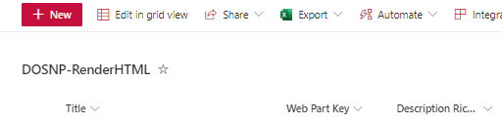

* A new panel will be opened as below.

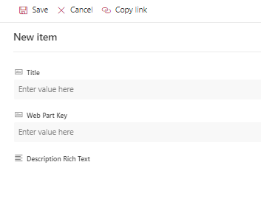

* Enter **Title**, **Description** **Rich Text** values.
* Enter **Background** **Image URL**. This image will be displayed in the carousel.
* Enter web part key. **Make sure to configure this value in web part properties.**

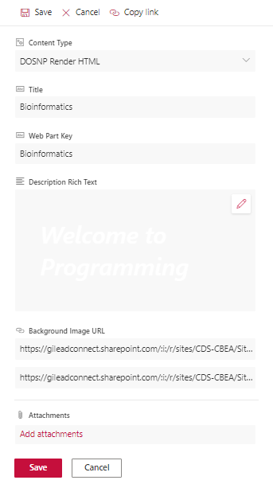

* Click on Save button.
* Item details will be saved into the list.

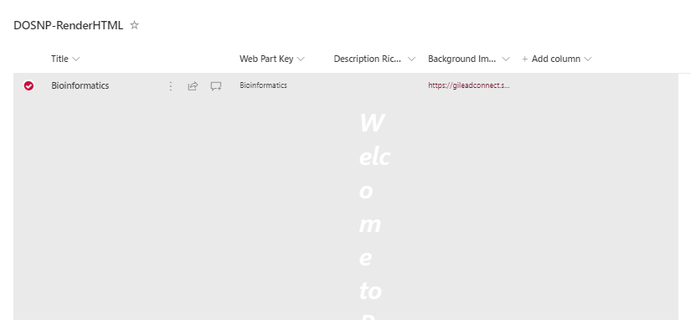

#### Retrieve data from list

* Click on edit web part. Web part property panel will be opened.

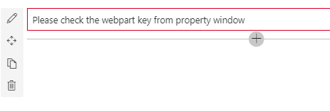

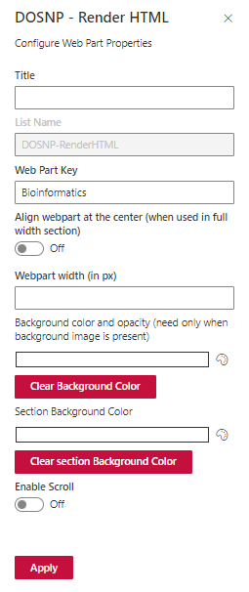

* Enter Title and web part key values.
* Select Webpart Alignment at the center.
* Select background color.
* Click on apply button.
* Select Enable Scroll to scroll the webpart images.
* Items from DOSNP-HTML data list with above mentioned web part key will be displayed.



* Save and publish the page.

# DOSNP - Events Calendar

## Prerequisites

Configure below web part tasks using **DOSNP - Dashboard** web part. Please refer **Configure Web Part Tasks** section in DOSNP - Dashboard web part.

1. Create Fields
2. Create Content Type
3. Create List with Content Type
4. Add configurations

## Properties

|  |  |  |  |
| --- | --- | --- | --- |
| Webpart Properties | Description | Values/Specifications | Comments |
| Webpart Title | Specifies the web part title | Any string value | Title value will be displayed as a web part heading. If there is no title specified, then there is no heading. |
| List Name | Specify the list name to display event items |  |  |
| Web Part Key | Specify web part key for registration | Any string value | Visible when registrations are enabled |
| Event Content Type | Specify the content type name | Any string value |  |
| Event Category | Specify the event category |  |  |
| Enable Registration | To enable registrations feature | * True * False | Default value is False |
| Registration email key | Specifies the email key (from “**DOSNP-EmailTemplates**” list) used for registration email |  |  |
| UnRegistration email key | Specifies the email key (from “**DOSNP-EmailTemplates**” list) used for unregistration email |  |  |
| Enable registration waitlist | Enables or disables waitlist feature | * True * False | Visible only when registrations are enabled |
| Waitlist email key | Specifies the email key (from “**DOSNP-EmailTemplates**” list) used for adding into the waitlist |  |  |
| Remove from waitlist email key | Specifies the email key (from “**DOSNP-EmailTemplates**” list) used for removing from waitlist |  |  |
| Waitlist confirmation email key | Specifies the email key (from “**DOSNP-EmailTemplates**” list) used for confirmation of the waitlist |  |  |
| Enable Presenters | Enables or disables presenter feature | * True * False | Visible only when registrations are enabled |
| Presenter Register email key | Specifies the email key (from “**DOSNP-EmailTemplates**” list) used for presenter register email |  |  |
| Presenter UnRegister email key | Specifies the email key (from “**DOSNP-EmailTemplates**” list) used for presenter unregister email |  |  |
| Show view all link | Enables or disables the view all link |  |  |
| View all link URL | Specifies the view all link URL |  |  |
| Enable Add Item | Enables add item features in the web part |  |  |
| Enable Target Audience | Enables or disables Target audience | * True * False |  |
| Type of audience target | Specifies type of targeting | * Security Group * Office Location |  |
| Security group details | Name of the groups that needs to be targeted |  | Separate by semicolon |
| Location details | Name of the location that needs to be targeted |  | Separated by semicolon |
| Number of items to display | Specify the item limit | Any integer value |  |
| Date Format | Specifies the date format | Default value is ‘**DD MMMM YYYY’** | A valid Date Format should be in UPPER CASE only |
| Webpart width | Specifies the webpart width |  |  |
| Webpart Display Type | Specify the webpart display type | * List * Filmstrip * Carousel |  |
| Interval in milliseconds | Specify the amount of time to delay between automatically cycling an item | Default value is 5 seconds |  |
| Number of items to be grouped | Specify the item limit | Any integer value |  |
| Item Display Type | Specify the item display type | * Compact * Expanded |  |

## How to Create Events Calendar List

* Go to Dashboard webpart.
* Select DOSNP – Events Calendar Webpart.
* Click on **‘Add Configuration’** checkbox and edit the configuration as shown below.

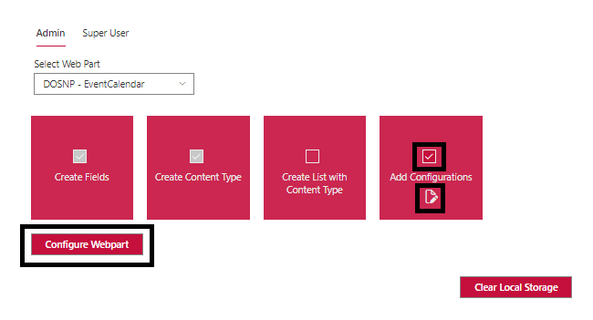

* Enter Event Calendar List Name and click on Save button.

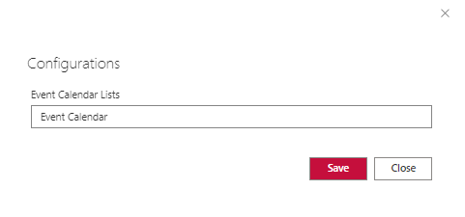

* Click on Configure Webpart.
* Refresh the page and select Create List with Content Type checkbox.
* Click on Configure Webpart, then the configured list will be created.

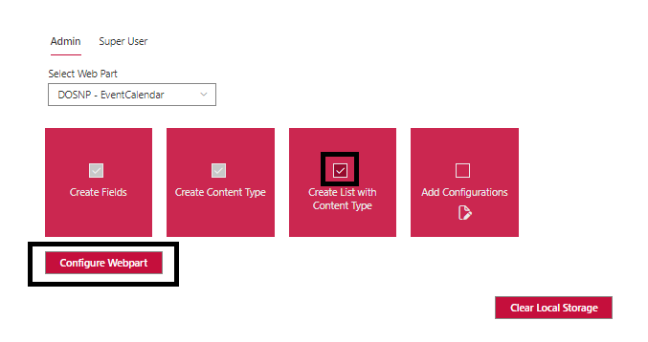

## Configure DOSNP - Events Calendar

* Edit the site page and add DOSNP - Events Calendar webpart to the page.
* Edit the web part.

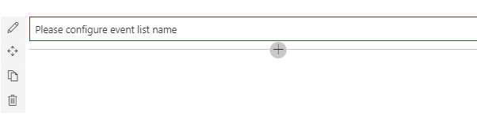

* A new panel will be opened as shown below.

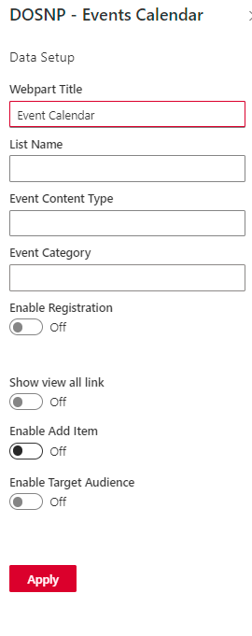

* Enter Web Part Title, List Name, Event Content Type, Event Category, Web Part Key, Registration email Key, UnRegistration Email key, Waitlist email key, Remove from waitlist email list key, Waitlist confirmation email key, Presenter Register email key, Presenter UnRegister email key, View all link URL.
* Select Enable Registration to enable registration feature.
* Select Enable Registration waitlist to enable waitlist feature.
* Select Enable Presenters to enable presenter feature.
* Select show view all link to display view all link in the web part.
* Enable add item to display add new item link in the web part.
* Enable target audience if required.
* Select type of audience target if target audience is enabled.
* Enter Security group details separated by semicolon if target audience is enabled.
* Enter location details separated by semicolon if target audience is enabled and click on Next button.

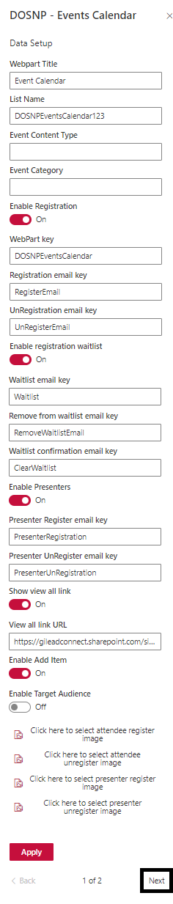

* Select the other properties as shown below based on the requirement.

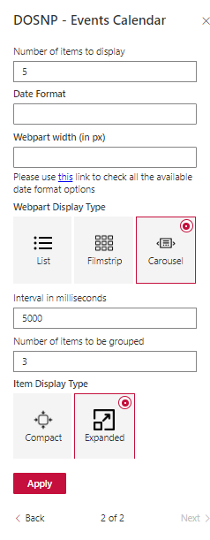

* Click on Apply button.
* Events from “DOSNPEventsCalendar123 “ with Event content type will be displayed in the web part.

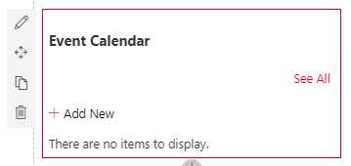

## Registration Process

There are two ways to register for DOSNP – Event Calendar.

* Attendee
* Presenter

## 22.5.1 Register as Attendee

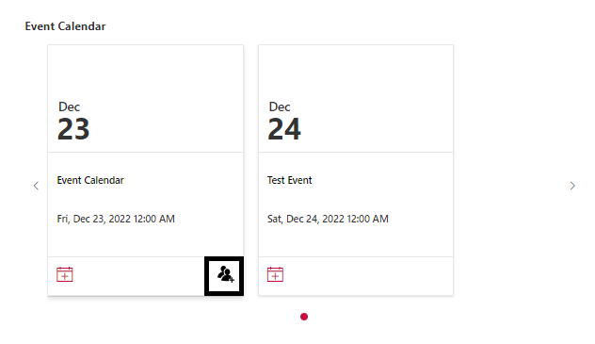

* When Register as Attendee is enabled Email Notification will be received to the registered member as shown below.

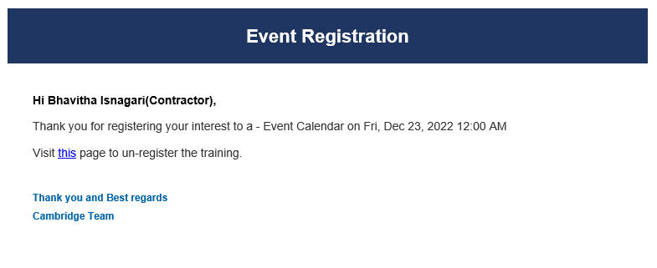

## 22.5.2 Register as Presenter

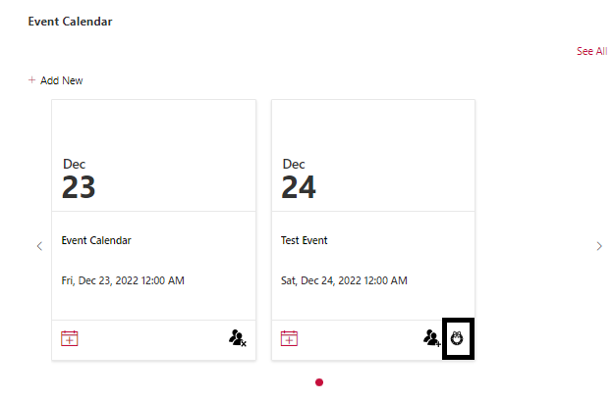

* When Register as Presentee is enabled Email Notification will be received to the registered presenter member as shown below.

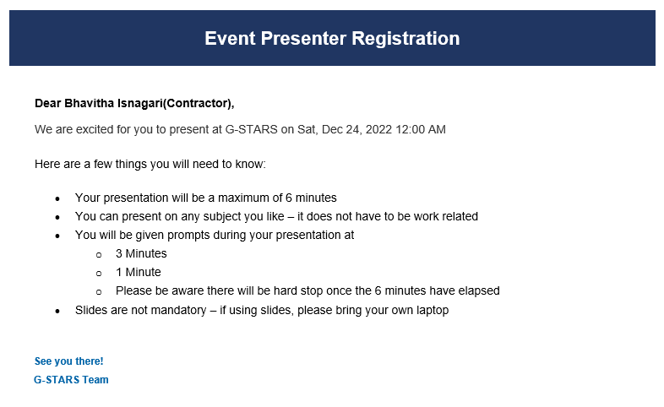

# DOSNP - Extension

## Configurations

|  |  |  |  |
| --- | --- | --- | --- |
| Title | Key | Type | Specifications/Comments |
| Footer Content Owner | FooterContentOwner | Text |  |
| Footer Owner Delve | FooterOwnerDelve | Text |  |
| Footer Powered By | FooterPoweredByLink | Text |  |
| Navigation Source | NavigationSource | Dropdown |  |
| Term ID | TermID | Text | NavigationSource must be Metadata to show TermID |
| Term Set ID | TermSetID | Text | NavigationSource must be Metadata to show TermSetID |
| Enable Header | EnableHeader | Boolean |  |
| Header Position | HeaderPosition | Dropdown | EnableHeader must be true to show HeaderPosition |
| Enable Apps On Header | EnableAppsOnHeader | Boolean | EnableHeader must be true to show HeaderPosition |
| Enable Admin Page Footer | EnableAdminPageFooter | Boolean |  |
| Admin Page URL | AdminPageURL | Text | EnableAdminPageFooter must be true to show AdminPageURL |
| Hide Footer Links (Separated by semicolon) | HideFooterLinks | Text |  |
| Category Details (Separated by semicolon) | FeedbackCategory | Text | Separated by Semicolon |
| Enable Apps On Footer(true/false) | EnableAppsOnFooter | Boolean |  |

## Edit Configurations from Dashboard

Configure below web part tasks using **DOSNP - Dashboard** web part. Please refer **Configure Web Part Tasks** section in DOSNP - Dashboard web part.

1. Create List with Content Type
2. Add Configuration

## Edit Configurations List

* Click on setting icon and then click on site contents as shown below.



* select DOSNP-Configurations list as shown below.

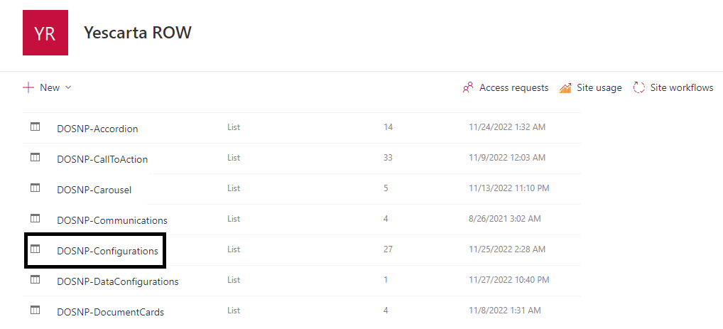

* A new page will be opened as shown below. Filter items using web part title.

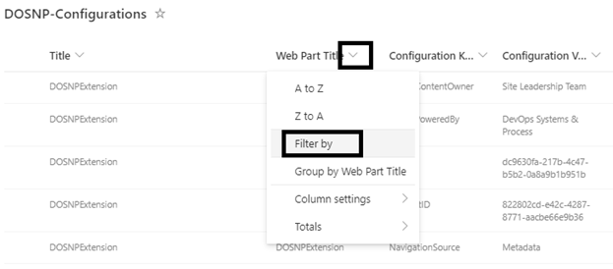

* Select DOSNP - Extension and click on apply button.

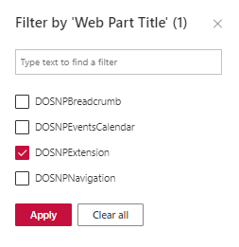

* All the DOSNP - Extension items will be filtered.
* Select the item which need to be updated and edit it as shown below.

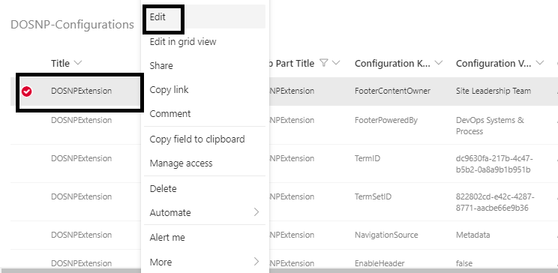

* Edit the required values and save.

# DOSNP - Repository

## Prerequisites

* Make sure “DOSNP-Repository” list is configured.
* DOSNP-Featured Content web part will be used to load the content below the tab.

## Properties

|  |  |  |  |
| --- | --- | --- | --- |
| Webpart Properties | Description | Values/Specifications | Comments |
| Web Part Title | Specify the web part title | Any String value |  |
| List Name | Specify the list name to display the data | Default value is ‘DOSNP-Repository’ |  |
| Web Part Key | Specify web part key to retrieve filtered items from a List | Any string value |  |
| Data Grouped By | Data will be grouped based on the specified value | * Category * Published Date * Title |  |
| Send Dynamic Data | This will Send Dynamic Data to Featured content web part on the page | * True * False | Select ‘True’ in case of sending data to featured content web part is required. |
| Select Data to be Displayed | Select the data to display in a format | * Link * Presentations * Video | Check or Uncheck the boxes if the data needs to be displayed or not. |
| Enable Target Audience | Specify if target audience needs to be enabled | * True * False |  |
| Type of audience target | Specify target audience type | * Security Group * Office Location | Target Audience can be enabled based on Security group or office location. |
| Security Group Details (separated by semicolon) | Name of the groups that needs to be targeted |  | Separated by semicolon |
| Location Details (separated by semicolon) | Name of the location that needs to be targeted |  | Separated by semicolon |
| Data Display Type | Specify how to display the tabs | * Pivot * Accordion |  |
| Accordion View Type | Select accordion view type | * All Expanded * All Collapsed * Expand Selected Index | * Select All Expand to display the content in expand mode. * Select Collapsed to display the content in collapsed mode. * Select “Expand Selected Index” to expand a particular section. |
| Default Accordion to expand | Specify default value to expand |  |  |
| Align webpart at the center (when used in full width section) | Specify this to align the web part to center |  | Only when used in full width section. |
| Web Part Width | Specify the web part width |  |  |
| Tabs Color | Specify the tab color |  |  |
| Tabs Font Color | Specify the tab font color |  |  |
| Web Part Background Color | Specify the web part background color |  |  |
| Section Background Color | Specify the section background color |  |  |

## Configure DOSNP - Repository

#### Add data to list:

* Navigate to DOSNP-Repository list (refer how to navigate to a list).
* A new page will be opened as below. Click on **New** button.

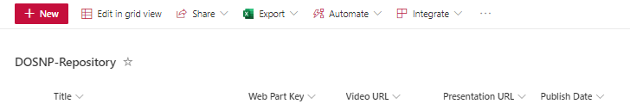

* A new panel will be opened as below.

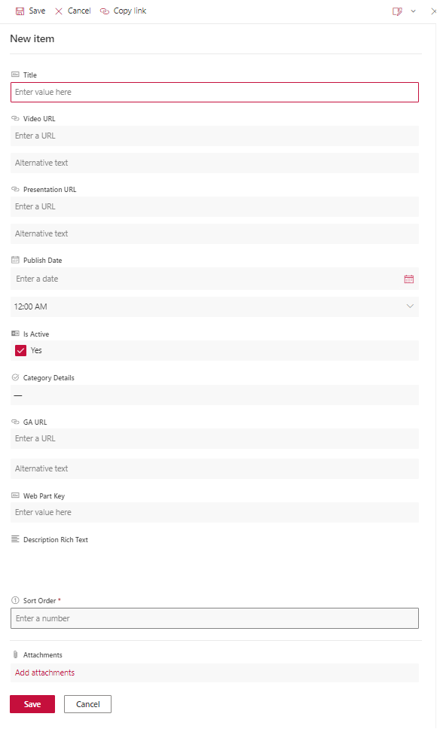

* Enter **Title**, **Video URL**, **Presentation URL**, **Published Date** values.
* Select Is Active to display the items. Else item won’t be displayed.
* Enter **Category Details**, **GA URL, Web Part Key, Description Rich Text and Sort Order.**
* Please note the **Web Part Key.** This key needs to be configured in the **DOSNP-Repository** web part properties
* **GA URL** will be a page URL with some content. This page content will be displayed under the tab.

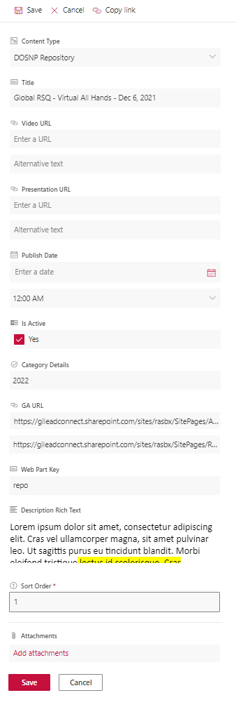

* Click on Save button.
* Item details will be saved into the list.

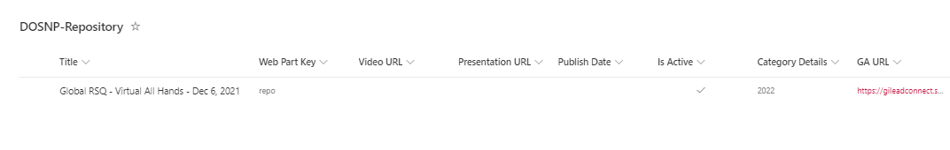

#### Retrieve data from List

* Edit the site page and add DOSNP - Repository web part to the page.
* Edit the web part.
* A new panel will be opened as shown below.

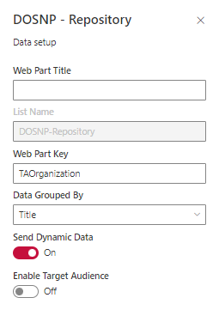

* Make sure List Name property is updated with “DOSPN-Repository”.
* Provide the Web Part Key value. Make sure you provide the same value which you saved in the list above.
* Select the Data Grouped By. Data will be grouped based on the selected value from the list.
* Select Send Dynamic Data to ‘True’.
* Click on ‘Apply’ button.
* Data from ‘DOSNP-Repository’ list will be displayed as below.
* All the list item Title’s will be tabs and The GA URL Page content will be displayed under the tab.
* The below image is an example of grouping the data based on Title.

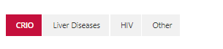

* The below image is an example of grouping data by Publishing date.
* Select the **Data Grouped By** property as Published date in DOSNP-Repository web part properties.

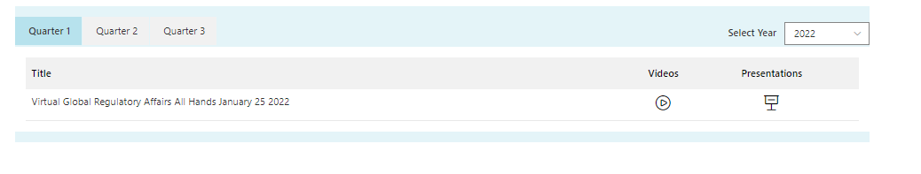

* Configure DOSNP – Featured Content web part below the DOSNP - Repository web part as explained in the Featured Content Section.

# DOSNP – Featured Content

## Prerequisites

* DOSNP – Featured Content web part will go in association with Repository component and also with Featured Links component.
* This web part will receive the data from DOSNP - Repository and DOSNP - Featured Links components and displays the given page url content into the featured content web part.

## Properties

|  |  |  |  |
| --- | --- | --- | --- |
| Webpart Properties | Description | Values/Specifications | Comments |
| Web Part Title | Specify the web part title | Any String value |  |
| Get dynamic data | Specifies to get the data dynamically from repository or featured links components | * True * False | **Default value is True** |
| Connect to source | Specify the connection to source | * DOSNP – Repository * DOSNP – Featured Links | * Select DOSNP – Repository if the data needs to be retrieved from repository component. * Select DOSNP – Featured Links if the data needs to be retrieved from featured links component. |
| DOSNP – Repository’s properties | Specify the content from repository’s properties |  | Default value is **Send Featured Content** |
| Send Featured Content’s properties | Specify the featured content’s properties |  | Default value is **pageURL** |
| DOSNP – Featured Links’s properties | Specify the content from featured links’s properties |  | Default value is **Send Featured Content** |
| Enable default SP Ribbon | Enables or Disables default sp ribbon | * True * False |  |
| Width of the iframe | Specify width of the iframe in px |  |  |
| Height of the iframe | Specify height of the iframe in px |  |  |
| Show page in iFrame |  | * True * False | Available only when Get dynamic data is false. |
| Page URL | Specify the page URL to display the content |  |  |
| Title | Specify the title | Any String value |  |
| Description | Specify the title description | Any String value |  |
| Navigation Button Text | Specify navigation button text to display | Any String value |  |
| Navigation URL | Specify navigation url |  | Navigate to particular page |
| Enable Target Audience | Specify if target audience needs to be enabled | * True   False |  |
| Type of audience target | Specify target audience type | * Security Group * Office Location | Target Audience can be enabled based on Security group or office location. |
| Security Group Details (separated by semicolon) | Name of the groups that needs to be targeted |  | Separated by semicolon |
| Location Details (separated by semicolon) | Name of the location that needs to be targeted |  | Separated by semicolon |

## Configure DOSNP – Featured Content

* Add DOSNP - Featured Content web part below to DOSNP - Repository web part.
* Edit the DOSNP - Featured Content web part.
* A new panel will be opened as shown below.

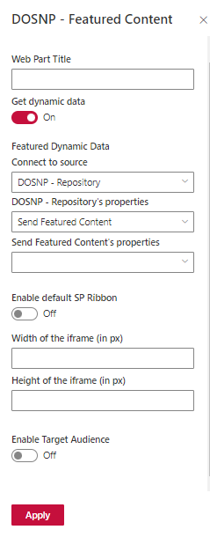

* Do not provide any **Web Part Title.**
* Select Get dynamic data to True.
* Select **Connect to source** value as **DOSNP-Repository.**
* Select **DOSNP - Repository's properties** as **Send Featured Content.**
* Select **Send Featured Content’s properties** as **pageURL** if required.
* Select Enable default SP Ribbon to True if required.
* Provide Width and Height based on the requirement.
* Enable Target Audience based on the requirement.
* Click on Apply button.

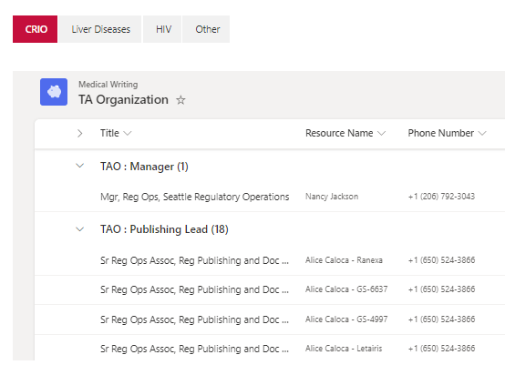

# DOSNP – My Favorites

## Prerequisites

Configure below web part tasks using **DOSNP - Dashboard** web part. Please refer **Configure Web Part Tasks** section in DOSNP - Dashboard web part.

1. Create Fields
2. Create Content Type
3. Create List with Content Type

## Properties

|  |  |  |  |
| --- | --- | --- | --- |
| Webpart Properties | Description | Values/Specifications | Comments |
| Title | Specify the web part title | Any String value |  |
| Quick Links List Name | Specify the quick links list name | Default value is ‘DOSNP-QuickLinks’ |  |
| My Favorites Links List Name | Specify the my favorites links list name | Default value is ‘DOSNP-MyFavorites’ |  |
| Web Part Key | Specify web part key to retrieve filtered items from a List | Any string value |  |
| Enable Current Page as Favorites | Enables or Disables page as favorites | * True * False |  |
| Layout | Specify layout type | * List * Filmstrip |  |
| Select Link Type | Specify link type | * Default Links * Custom Links |  |
| Number Of Items To Display | Specify the item limit to display | Default value is 30 |  |
| Show View All Link | Enables or disables view all link | * True * False |  |
| Select View All Type | Specify to display view all link | * Panel * Page | Default value is Panel |
| Page URL | Specify page URL to open view all link in a new page |  | Once view all links is clicked, it redirects to a new page. |
| Enable Search | Enable search option to search for specific item | * True * False |  |
| Enable Items as Favorites | Enables or Disables items as favorites | * True * False |  |
| Enable Add New Links | Enables or Disables add new links | * True * False | Visible only when select link type is **‘Custom Links’** |
| Enable Delete Favorite Links | Enables or Disables delete favorite links | * True * False | Visible only when select link type is **‘Custom Links’** |

## Configure DOSNP – My Favorites

#### 26.3.1 Add data to list:

* Navigate to DOSNP-MyFavorites list (refer how to navigate to a list).
* A new page will be opened as below. Click on **New** button.

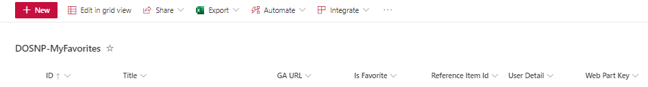

* A new panel will be opened as below.

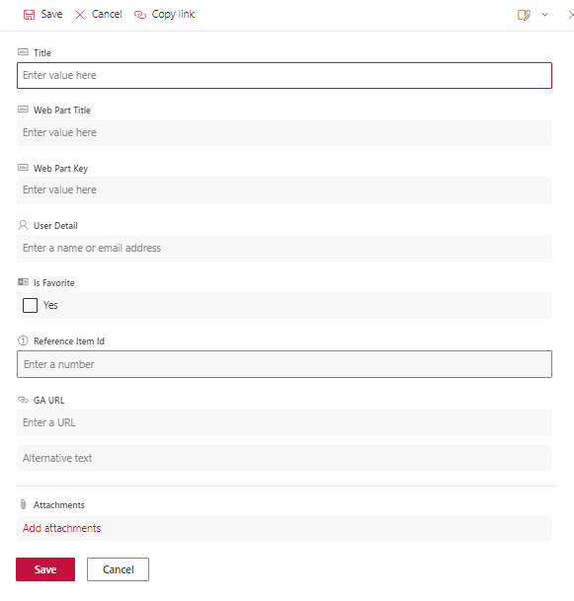

* Enter **Title**, **Webpart Title and User Details** values.
* **GA URL** will be a page URL with some content. This page content will be displayed under the tab.
* Select Is Favorite to display the items in MyFavorites webpart properties. Else item won’t be displayed.
* Please note the **Web Part Key.** This key needs to be configured in the **DOSNP-MyFavorites** web part properties.
* Enter Reference Item Id and click on Save button.

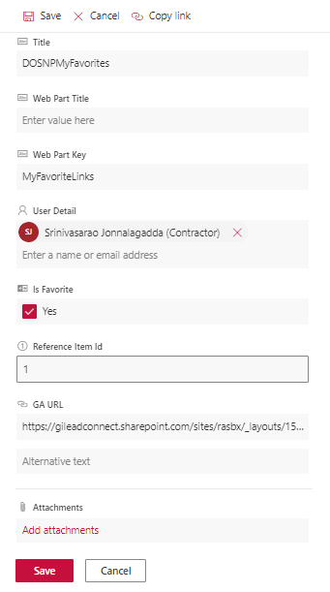

* Item details will be saved into the list.

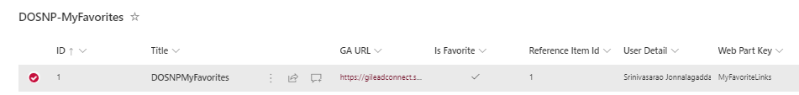

#### Retrieve data from List

* Edit the site page and add DOSNP - MyFavorites web part to the page.
* Edit the web part.
* A new panel will be opened as shown below.

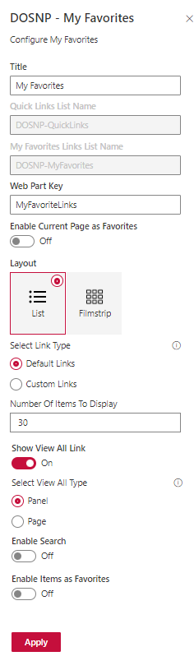

* Enter Title value.
* Provide the Web Part Key value. Make sure you provide the same value which you saved in the list above.
* Select Enable Current Page as Favorites if required.
* Select Layout and Link Type.
* Select Default Link Type to display the default links.
* Select Custom Link Type to display the custom links.
* Enter Number Of Items To Display value.
* Enable Show View All Link and select View All Type.
* Select View All Type as Panel to open in panel.
* Select View All Type as Page to open in a new page.
* Enable Search option if required.
* Enable Items as Favorites if required.
* Click on ‘Apply’ button.
* Data from ‘DOSNP-MyFavorites’ list will be displayed as below.
* When Layout is selected as List.

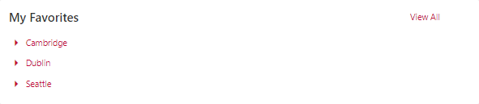

* When Layout is selected as Filmstrip.

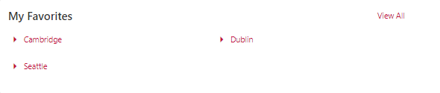

# Clear the Cache

If the data is not displayed in the webpart, please follow the below two steps :

* Clearing the local cache
* Clearing the cache from the list

## Clearing the Local Cache

* Go to the Dashboard page and click the **Clear Local Storage** button.

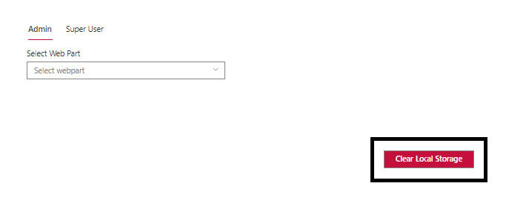

## Clearing the Cache from List

* Then go to **DOSNP-DataConfigurations** list and delete the entries, if any, or refresh and delete them.

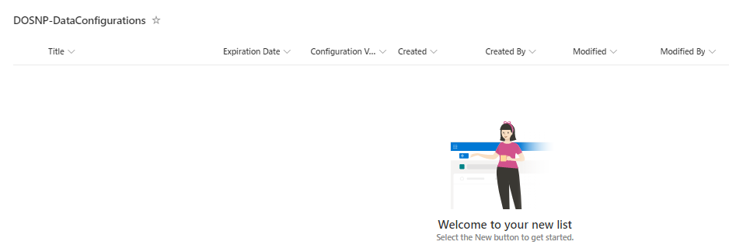

* Go to the current page and refresh it.
* If in case of Termstore then clear both **Local Storage** and **List Cache.**